ATOMIC PHYSICS: The electron and Semiconductors

Remember to photocopy 4 pages onto one sheet by going A3→A4 AND back to back on the photocopier

Student name: ________________________________

This booklet contains every higher and ordinary level question that has appeared on an exam paper on this topic from 2002–2023
Worked solutions to Ordinary Level Maths questions can be found at the end of the booklet.
Fully worked solutions to all higher level past papers can be found on the homepage of thephysicsteacher.ie

Screencasts of all topics plus a wide range of other resources via this link

You can find this document plus all other booklets on the homepage of thephysicsteacher.ie
Last updated: 04/08/2024
Noel Cunningham
Contents
1: The electron 2
Student notes 2
Properties of the electron 2
Thermionic emission 3
The cathode ray tube 3
Energy associated with an electron: W = QV 4
The electronvolt (eV) 4
Bohr model of the atom 5
Emission spectrums 5
An electron’s potential energy (QV) can be converted to kinetic energy 7
Electrons in a magnetic field 8
The photoelectric effect 9
Einstein’s explanation 9
Mathematically: the photon as a packet of energy* 10
Work function 11
Maths questions on the photoelectric effect 13
Increasing the intensity of the incident light (I) 15
Theory questions on the photoelectric effect 16
The photocell 17
X-Rays 18
X-Ray Maths questions 19
Extra reading 21
An introduction to quantum physics 21
SLOP 25
The electron exam questions 2002 - 2023 28
The Millikan oil drop experiment 28
Cathode ray tube – Ordinary level 29
Cathode ray tube – Higher level 30
The photoelectric effect / the photocell Ordinary level 31
The photoelectric effect / the photocell Higher level 33
The dual nature of light 35
X-Rays Ordinary level 36
X-Rays Higher level 38
X-Rays and the photoelectric effect 39
Structure of the atom and emission spectrums Higher Level 41
2: Semiconductors 42
Introduction 42
Student Notes 42
Doping 45
Why semiconductors are so powerful: The p-n junction 46
How a depletion region is formed 46
Current flow across a p-n junction 47
Graph of current against voltage for a semiconductor diode 48
Demonstrating the action of a diode 48
The light-emitting diode (LED) 49
SLOP 58
Semiconductor exam questions 2002 - 2022 61
Ordinary Level 61
Higher Level 62

1: The electron

'The electron is a theory we use; it is so useful in understanding the way nature works that we can almost call it real.'
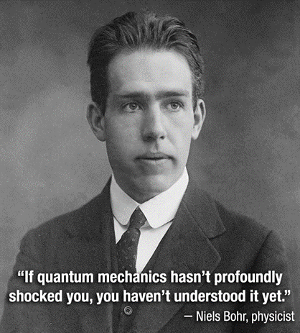
Nobel Prize winning physicist Richard Feynman

“The more successful quantum physics gets, the sillier it looks”
Albert Einstein

“No-one understands quantum physics”
Richard Feynman

“Curiouser and curiouser,” cried Alice
Alice’s Adventures in Wonderland

Student notes

Properties of the electron
The electron has a small mass (relative to the proton and neutron), negative charge and orbits the nucleus in the atom

You don’t have to know the actual charge of an electron (1.6 × 10⁻¹⁹ C), but you do need to know that the man responsible for first measuring this charge was Robert Millikan. I have no idea why you need to know this.

The term electron was coined by an Irishman called George Stoney.

Thermionic emission

Thermionic emission is the emission of electrons from the surface of a hot metal.

The cathode ray tube
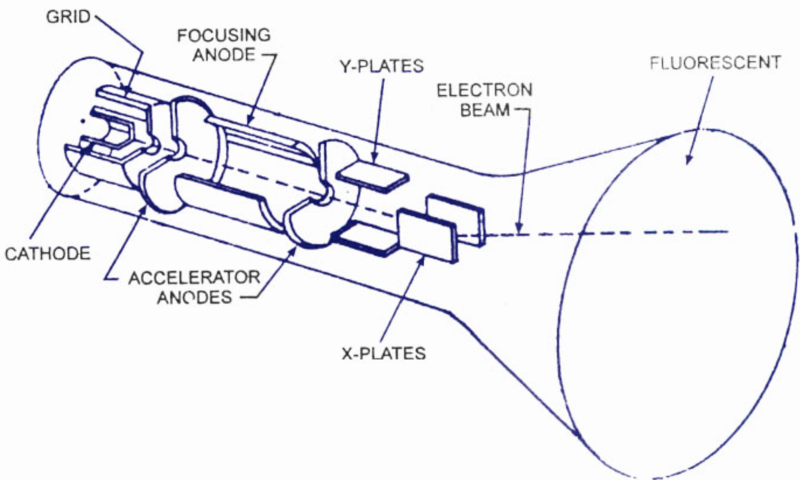

Operation
- A current is passed through the heating coil, causing it to heat the cathode which in turn causes electrons to be emitted (by thermionic emission).
- Because of the high potential difference between the cathode and anode the electrons are accelerated across the tube towards the anode. As a result a current flows in the circuit.
- Electrons which pass through the hole in the middle of the anode continue until they hit the fluorescent screen.
- The stream of electrons can be deflected by electric or magnetic fields, which are generated from the X and Y plates.
- The voltage on the Y-plates is adjusted to make the cathode rays (or stream of electrons) move up or down.
- The voltage on the X-plates is adjusted to make the cathode rays move left or right. The result is that the rays can move across the computer or television screen.

Uses of the cathode ray tube
Basically it can be used anywhere a small electrical signal is produced.
- Cathode Ray Oscilloscope (CRO); used in electronics as a diagnostic tool.
- The ECG (electrocardiogram) is used in medicine to display electrical signals in the heart.

Cathode rays are streams of high-speed electrons
They travel from the cathode in straight lines, cause certain substances to fluoresce and can be deflected in electric and magnetic fields.
They can produce x-rays when they strike heavy metals

Energy associated with an electron: W = QV

An electron’s potential energy is given by the formula W= QV
W = QV

This leads us to the concept of the electron-volt.

The electronvolt (eV)
The electronvolt (eV) is the energy lost or gained by an electron when it accelerates through a potential difference of one volt.

From the formula W = QV (and knowing that the charge on an electron Q = 1.6 × 10^{–19} C)
we can calculate that the energy lost or gained = (1.6 × 10^{–19})(1) = 1.6 x 10^{–19} J

Therefore
1eV =1.6 x 10^{–19} joules

2022 Question 5  Calculate how many electronvolts are in a kilowatt-hour. | First we need to find out how many joules are in one kW-hour.  No. of joules in one kW-hour = (1000)(60)(60)  = 3.6 × 10⁶ joules  Now we need to convert 3.6 × 10⁶ joules to electronvolts  1 eV = 1.6 × 10^{–19} joules  $Answer=\frac{{3.6×10}^{6}}{{1.6×10}^{-19}}$ = 2.25 × 10²⁵ eV

Converting from electronvolts to joules or vice versa
Converting from joules to electronvolts
Note that an electronvolt is a very small unit of energy, so when converting from joules to electronvolts the number should get much bigger. We can only achieve this if we divide the number of joules by a very small number, so to convert from joules to electronvolts by need to divide that number by 1.6 × 10^{–19}.

Converting from electronvolts to joules
Note that the joule is a relatively large unit of energy, so when converting from electronvolts to joules the number should get much smaller. We can only achieve this if we multiply the number of electronvolts by a large number, so to convert from electronvolts to joules by need to multiply that number by 1.6 × 10^{–19}.

Bohr model of the atom
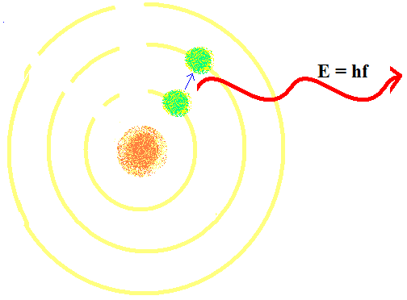
The Danish physicist Neils Bohr developed his theory of the arrangement of the electrons along the following lines:
- Electrons could only inhabit certain discrete levels or orbitals.
- If an electron absorbs energy (in the form of heat or light) then it can ‘jump’ to a higher orbital or energy state.
- This state is unstable and therefore temporary.
- When the electron ‘falls’ back down to a lower state it emits electromagnetic radiation of frequency f, corresponding to a packet of energy (photon) of size hf = E₂ – E₁ where E₂ and E₁ are the energies associated with the two electron levels and h is a constant known as Planck’s constant.
- Each transition has a specific energy. If this radiation is in the visible part of the electromagnetic spectrum then we see it as light of a specific colour.
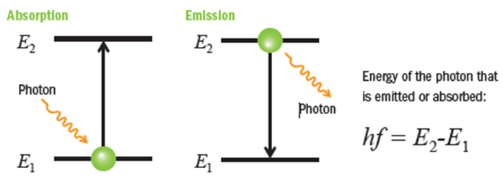

Bohr won a Nobel Prize for this work, and in particular for coming up with the mathematical link between energy and frequency (E = hf).

Emission spectrums

A simple gas like hydrogen has a number of unique energy levels. When electrons fall from a higher level to a lower level they give out a specific frequency of light. What we see when we look at hydrogen gas is a combination of all of these colours – the overall effect is that hydrogen gas appears yellow. However if you look at hydrogen gas through a diffraction grating these different colours form constructive interference at different angles so we see a series of coloured lines. This is known as an emission spectrum.
The different colours correspond to the frequency of the electromagnetic radiation emitted.

This series of lines is known as an emission spectrum.

Emission spectrums: exam questions

2020 Question 11 [Higher Level]
Describe with the aid of a labelled diagram the Bohr model of the atom and use the model to explain emission line spectra.
Solution
- Nucleus
- Electrons in different energy levels
- Electrons given energy
- Rise to higher energy level
- Fall to lower energy level
- Photon/light emitted
2016 Question 11 [Higher Level]
- Quantum mechanics is used to explain how electrons in atoms produce line emission spectra.
Describe how these spectra are produced.
- State two differences between photons and electrons.

2017 Question 9 [Higher Level]
- Explain, using the Bohr model, how line spectra are formed.
- Draw a labelled diagram of a spectrometer and describe how a spectrometer and diffraction grating can be used to observe (i) a line spectrum and (ii) a continuous spectrum.

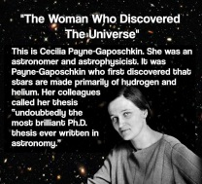

An electron’s potential energy (QV) can be converted to kinetic energy

Imagine that a book is dropped from a height h and accelerates towards the ground. You are asked to find its speed when it hits the ground. To solve this you can use potential energy at the top = kinetic at the bottom where potential energy = mgh and kinetic energy = ½ mv². We can do the same for a charged particle accelerating in an electric field. The kinetic energy is still = ½ mv² but this time the electrical potential energy is given by the formular W = QV.
QV = ½ mv²

2020 Question 11 [Higher level]  Cathode rays are accelerated through a potential difference of 4 kV in a cathode ray tube.  Calculate the maximum speed of an electron in the tube. | Charge of electron = 1.6×10⁻¹⁹ C  Mass of electron = 9.1×10⁻31 kg  potential energy lost = kinetic energy gained  QV = ½ mv²  (1.6×10⁻¹⁹)(4000) = ½ (9.1×10⁻³¹)(v²)  v = 3.75 ×10⁷ m s⁻¹

Electrons in a magnetic field
A beam of electrons moving at right angles to a magnetic field will move in a circular path*.

We know (don’t we?) that the force on a charge q moving at velocity v in a magnetic field B is given by

F = Bqv ⇒ (where e = charge on an electron)
F = Bev

We also know from circular motion that when a mass m is moving in a circular path with radius r at constant speed v it experiences a centripetal force F, where
$$F=\frac{{mv}^{2}}{r}$$

$$\frac{{mv}^{2}}{r}=Bev$$

Now putting these two together we get

By rearranging this expression we can find the radius of orbit if we know everything speed or vice versa.
Note for each of the previous three equations v = velocity, not voltage

2003 Question 9 [Higher Level]
- An electron is emitted from the cathode and accelerated through a potential difference of 4kV in a cathode ray tube (CRT). How much energy does the electron gain?
- What is the speed of the electron at the anode? (Assume that the speed of the electron leaving the cathode is negligible.)
- After leaving the anode, the electron travels at a constant speed and enters a magnetic field at right angles, where it is deflected. The flux density of the magnetic field is 5 × 10^{–2} T.
Calculate the force acting on the electron.
- Calculate the radius of the circular path followed by the electron, in the magnetic field.
- What happens to the energy of the electron when it hits the screen of the CRT?

mass of electron = 9.1 × 10^{–31} kg; charge on electron = 1.6 × 10^{–19} C

- How much energy does the electron gain?
The final kinetic energy gained by the electron is equal to the initial (electrical) potential energy lost by the electron.
The potential energy is given by the equation W = QV
W = (1.6 × 10^{–19})(4000) W = 6.4×10⁻¹⁶ J

- What is the speed of the electron at the anode?
Kinetic energy = ½ mv² 6.4 ×10⁻¹⁶ = ½ (9.1 × 10⁻³¹)(v²) v =3.75 × 10⁷ m s⁻¹

- Calculate the force acting on the electron.
B = 5 × 10^{–2} T
F = Bev = (5 × 10^{–2})(1.6 × 10^{–19})( 3.75 × 10⁷) F = 3.0 ×10⁻¹³ N

- Calculate the radius of the circular path followed by the electron, in the magnetic field.
$F=\frac{mv^{2}}{r}$ $r=\frac{mv^{2}}{F}$ $r=\frac{(9.1 × {10}^{-31}){(3.75 ×{10}^{7})}^{2}}{3.0 ×{ 10}^{-13}}$ r = 4.3×10⁻³ m

- What happens to the energy of the electron when it hits the screen of the CRT?
It gets converted to light.

The photoelectric effect

The photoelectric effect is the emission of electrons from the surface of a metal due to electromagnetic radiation of a suitable frequency falling upon it.
Demonstration
Procedure:
- Charge a gold leaf electroscope negatively such that the leaves separate.
- Shine visible light on the zinc plate.
Result: nothing happens, regardless of the intensity (power) of the light or how long it is shining for.
- Shine ultraviolet light on the zinc plate.
Result: the leaves immediately collapse.

Conclusion
Shining UV light on the zinc plate liberates electrons from the zinc and therefore the legs become neutralised and fall back together.

Einstein’s explanation
- The light coming from the UV lamp consists of packets called ‘photons’.

- If the photons contain enough energy they can get absorbed by an electron on the surface of the zinc metal.
- Each photon gives all its energy to one electron.
- A certain amount of this energy (known as the work function) goes to liberating (releasing) the electron.
- The remainder appears as kinetic energy of the liberated electron.
- Shining visible light has no effect on the apparatus because the packets of energy associated with visible light are too small (frequency is too low) to liberate (release) electrons.

This ‘proved’ that electromagnetic radiation (including light) is composed of particles (called photons).
Which is ever so slightly problematic because we have already ‘proved’ that light is a wave (double slit experiment). Ladies and gentlemen, I give you one of the greatest unresolved dilemmas in all of science.

A photon is therefore a bundle (discrete amount) of electromagnetic radiation.

A photon checks into a hotel and the porter asks him if he has any luggage.
The photon replies: “No, I’m travelling light.”

Mathematically: the photon as a packet of energy*
E = hf
The energy associated with each packet of energy (photon) is given by

h is known as Planck’s constant (its value is 6.6 × 10⁻³⁴ J s) and f is the frequency of the wave.

2022 Question 12 [Ordinary Level]  The threshold frequency for zinc is 6.5 × 10¹⁴ Hz.  (i) Calculate the wavelength of light of this frequency.  (ii) Calculate the energy of a photon of this frequency. | h = Planck’s constant; 6.6 × 10⁻³⁴ J s  f represents frequency.  Calculate the wavelength of light of this frequency.  c = f λ  $λ=\frac{c}{f}=\frac{{3×10}^{8}}{{6.5×10}^{14}}$ = 4.6 × 10^{–7} m  Calculate the energy of a photon.  E = hf = (6.6 × 10^{–34})(6.5 × 10¹⁴) = 4.3 × 10^{–19} J
2016 Question 11 [Higher Level]  Calculate the energy of a photon of green light, which has a wavelength of 510 nm. | h = Planck’s constant; 6.6 × 10⁻³⁴ J s  f represents frequency. We don’t have a value for frequency but we can work it out using c = fλ.  E = hf $f= \frac{c}{λ}$  $$E=h\frac{c}{λ}$$  $$E={(6.6 × 10}^{-34})(\frac{{3× 10}^{8}}{{510× 10}^{-9}})$$  E = 3.89 × 10^{–19} J

Work function

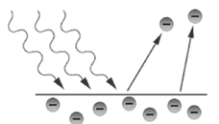
The energy required to just liberate an electron from the surface of an atom is known as the work function of the metal and is given the Greek symbol Ф (pronounced “fee”).

Because φ is a discrete amount of energy, it can in turn be represented by the formula φ = hf₀, where f₀ is called the threshold frequency.

Let’s look at this again from another perspective:
The energy of the incoming (‘incident’) photons of light needs to be equal to or greater than the work function in order to liberate an electron.
The energy of a photon is determined by the frequency of the light associated with that photon (from E = hf) so if the frequency of the incident light is too low (below threshold frequency) then the energy of the photon will be too small and an electron will not be liberated.
hf = φ + ½mv²

The equation is known as Einstein’s photoelectric law:

This is the same equation in a more user-friendly format:
Energy of incident photon = Energy required to free an electron + kinetic energy of photo-electron
hf (or $h(\frac{c}{λ})$ = work function + $\frac{1}{2}mv^{2}$

2004 Question 9 [Higher Level]
The work function of zinc is 4.3 eV. Calculate the threshold frequency of zinc.

Solution
First we need to convert the energy from eV to joules, using 1eV = 1.6 × 10^{–19} joules}

Work function = 4.3 eV = (4.3)(1.6 × 10^{–19}) J
= 6.88 × 10^{–19} joules

Next we use E = hf₀ to calculate the threshold frequency
E = hf₀ $f_{0}=\frac{E}{h}$ $f_{0}=\frac{6.88 × {10}^{-19}}{6.6 × {10}^{-34}}$ f₀ = 1.04 × 10¹⁵ Hz

So one more time

Maths questions on the photoelectric effect

Remember there are three energy terms here: you need to clarify two of those terms in order to work out the third. In each of the questions below we are being asked to find the kinetic energy of the emitted electron. From there we may be asked to calculate the velocity of the emitted electron, in which case we just use kinetic energy = ½mv².

Begin by writing out the equation in words. Circle the two terms you have information about - you may need to convert to joules for this section. See examples underneath.
Energy of incident photon = Energy required to free an electron + kinetic energy of emitted electron
hf (or $h(\frac{c}{λ})$ = work function ($hf_{0})$ + $\frac{1}{2}mv^{2}$

2004 Question 9 [Higher Level]
The zinc metal is illuminated with ultraviolet light of wavelength 240 nm.
The work function of zinc is 4.3 eV.
- Calculate the threshold frequency of zinc.
- Calculate the maximum kinetic energy of an emitted electron.

- Calculate the threshold frequency of zinc.
{First we need to convert the energy from eV to Joules, using 1eV = 1.6 × 10^{–19} joules}
The symbol for work function is φ, so φ = 4.3 eV = (4.3)( 1.6 × 10^{–19}) joules = 6.88 × 10^{–19} joules

Next we use E = hf₀ to calculate the threshold frequency
E = φ = hf₀ ⇒ $f_{0}=\frac{E}{h}$ $f_{0}=\frac{E}{h}$ $f_{0}=\frac{6.88 × {10}^{-19}}{6.6 × {10}^{-34}}$ f₀ = 1.04 × 10¹⁵ Hz

- Calulate the maximum kinetic energy of an emitted electron.

Energy of incident photon = Energy required to free an electron + kinetic energy of photo-electron
hf = φ + E_{k}

Remember that φ (the work function) = 6.88 × 10^{–19} joules so the equation becomes:
hf = 6.88 × 10^{–19} + E_{k}

We don’t know the frequency of the incident ultraviolet light, but we do know that the wavelength is 240 nm so we can work out the frequency using c = fλ

$f=\frac{c}{λ}$ $f=\frac{3.0 ×{10}^{8}}{240 ×{10}^{-9}}$ = 1.25 × 10¹⁵ Hz

hf = 6.88 × 10^{–19} + E_{k}

[(6.6 × 10^{–34})(1.25 × 10¹⁵) = 6.88 × 10^{–19} + E_{k}

E_{k} = [(6.6 × 10^{–34})( 1.25 × 10¹⁵)] - (6.88 × 10^{–19})
⇒ E_{k} = 1.37 × 10⁻¹⁹ joules
2014 Question 5 [Higher level]  The work function of tungsten is 4.50 eV.  Calculate the maximum kinetic energy of an electron ejected from a tungsten surface when electromagnetic radiation whose photon energy is 5.85 eV shines on the surface. | Energy of incident photon = Work function + kinetic energy of electron  5.85 eV = 4.50 eV + kinetic energy of electron  Because 2 of the terms are given in terms of eV it makes more sense to leave those as eV and then just convert the kinetic energy (once we have it in eV) to joules at that stage.  Kinetic energy of electron = 5.85 – 4.5 = 1.35 eV  1 eV = 1.6 × 10⁻¹⁹ J  So 1.35 eV = (1.35)( 1.6 × 10⁻¹⁹) = 2.16 × 10⁻¹⁹ J
2004 Question 9 [Higher Level]  Zinc metal is illuminated with ultraviolet light of wavelength 240 nm.  The work function of zinc is 4.3 eV.  Calculate the maximum kinetic energy of an emitted electron. | Energy of incident photon = Work function + kinetic energy of electron  5.85 eV = 4.50 eV + kinetic energy of electron
2004 Question 12 (d) [Higher Level]
The work function of iron is 4.7 eV.
Calculate the maximum kinetic energy of an emitted electron when ultraviolet radiation of wavelength 200 nm is incident on iron.

2022 Question 14 (c) [Higher level]
Light of wavelength 450 nm is incident on a metal that has a work function of 2.4 eV.
Calculate the maximum speed of the emitted electrons.
More challenging questions
2009 Question 8 [Higher Level]
An investigation was carried out to establish the relationship between the current flowing in a photocell and the frequency of the light incident on it. The graph illustrates the relationship.
Using the graph, calculate the work function of the metal.
What is the maximum speed of an emitted electron when light of wavelength 550 nm is incident on the photocell?

Increasing the intensity of the incident light (I)

Remember that intensity is defined as power/area, and power is defined as work divided by time, so intensity is therefore a reflection (sorry) of the energy that falls on the metal surface every second.
This energy is equal to the energy in one photon multiplied by the number of photons.
So if the intensity of the light increased (technically we should be calling it ‘electromagnetic radiation’ rather than ‘light’) then either the number of photons landing on the surface every second increased or the energy/frequency associated with each photon increased (or both).
What effect does this have? It depends on which of those two effects was involved:

If the number of photons incident on the metal increases | Each photon ‘liberates’ one electron, so if the number of photons increases then the number of electrons emitted from the metal will increase so the current carrying these electrons back to the cathode will increase.
If the frequency of the incident light increases | The frequency of the incident light determines the energy of the incident photon. Some of this gets ‘used up’ to release an electron and whatever is ‘left over’ becomes the kinetic energy of the released electron. So increasing the frequency of the incident light will increase the kinetic energy of the emitted electron.

2021 14 (c) HL  In the photoelectric effect electrons are emitted from the surface of a metal when the incoming light of intensity I has a frequency f that exceeds a certain value fo, the threshold frequency.  Describe what happens when . . . | The reference to whether f is greater than or less than fo is significant because if the frequency of the incident light is less than fo then the energy of the incident photon is too small and nothing at all happens.
f > fo , f is constant and I is increasing | If the intensity increases while f is constant then it means that the number of photons hitting the metal was increasing and because each photon releases one electron the end result is that more electrons are emitted from the metal and all will have the same energy/speed.
f > fo , f is increasing and I is constant???? | same number of electrons emitted  but with greater energy/speed????
f < fo , f is constant and I is increasing | No electrons emitted

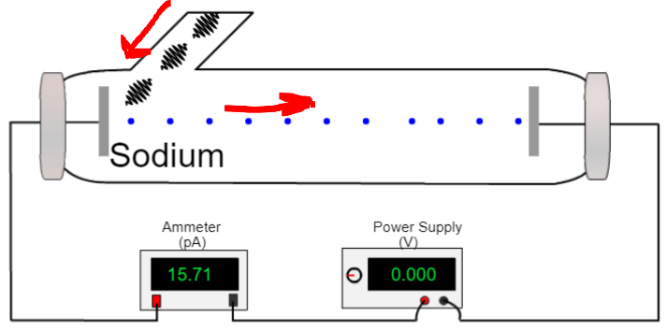
In practice physicists use an apparatus like the one shown here to study the photoelectric effect in more detail.
The current reflects the number of electrons emitted per second and increasing the voltage increases the speed of the electrons. There are a lot of really useful simulations out there in www land and they’re well worth looking at in order to fully appreciate the effect of adjusting any one of the many variables.
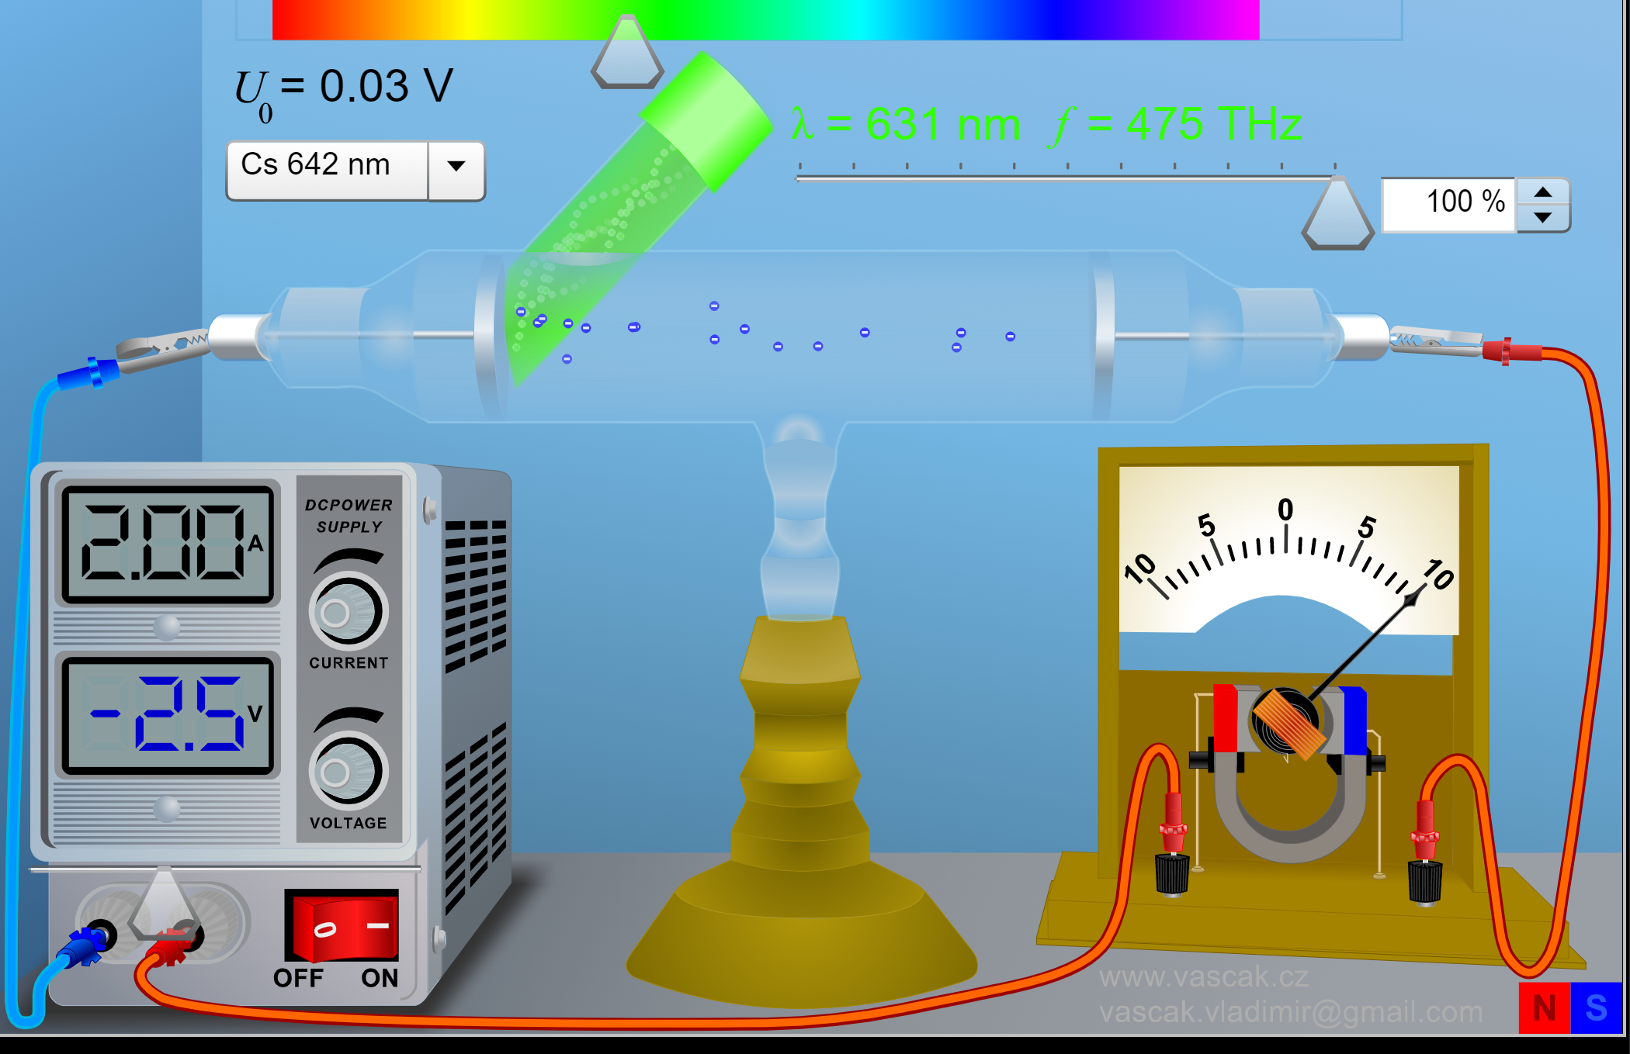 | 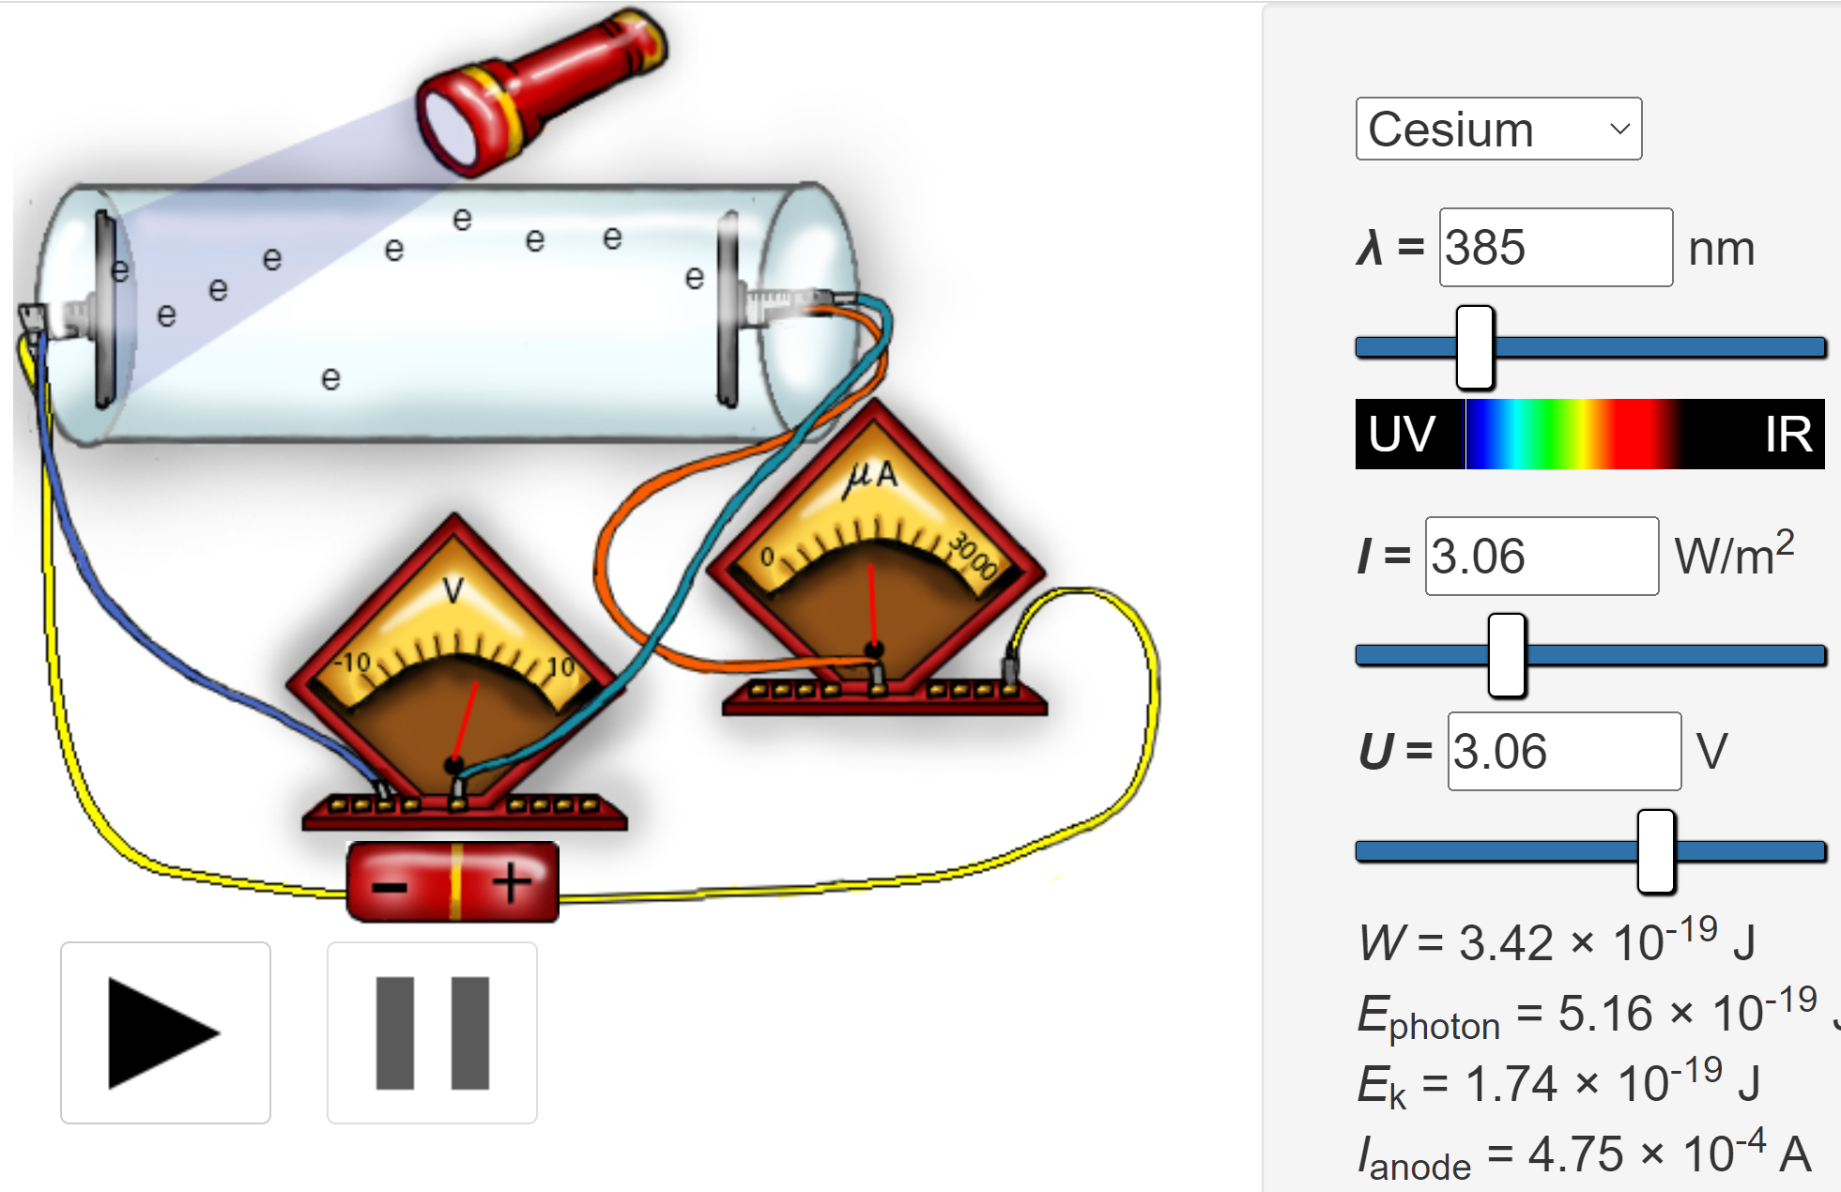 | 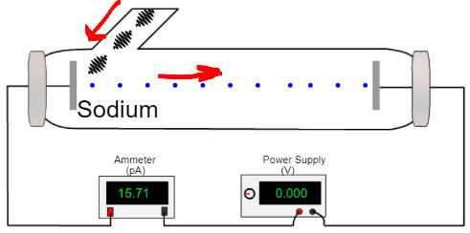
www.vascak.cz | www.viten.no | applets.kcvs.ca

Theory questions on the photoelectric effect

2022 Question 12 [Ordinary Level]  To ensure the photoelectric effect occurs, the light must be of a suitable frequency to release the electrons.  Describe what happens if the frequency of the incident light is below the threshold frequency. | Nothing happens / photoelectric effect does not occur
2004 Question 9 [Higher Level]  A freshly cleaned piece of zinc metal is placed on the cap of a negatively charged gold leaf electroscope and illuminated with ultraviolet radiation.  Explain why the leaves of the electroscope collapse. | Photoelectric emission occurs (electrons get emitted from the surface of the metal).  The leaves lose their excess charge and therefore collapse.
Explain why the leaves do not collapse when the zinc is covered by a piece of ordinary glass. | Ordinary glass absorbs UV light (does not allow UV light to pass through)
Explain why the leaves do not collapse when the zinc is illuminated with green light. | The energy associated with photons of green light is too low for the photoelectric effect to occur, so no electrons are emitted from the electroscope.
Explain why the leaves do not collapse when the electroscope is charged positively. | Any electrons emitted are attracted back to the positively charged electroscope.
2009 Question 8 [Higher Level]  Explain why a current does not flow in the photocell when the frequency of the light is less than 5.2 × 10¹⁴ Hz. | Because the frequency is less than the threshold frequency so the individual photons of the incident light do not contain enough energy to cause an electron to be released from an atom.
The relationship between the current flowing in a photocell and the intensity of the light incident on the photocell was then investigated. Readings were taken and a graph was drawn to show the relationship.  Draw a sketch of the graph obtained. | 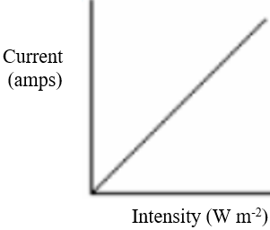  Current is directly proportional to Intensity {each photon releases one electron, so if you have twice as many photons you will have twice as many electrons}, so a straight line graph through the origin is required.
2022 Question 14 (c) [Higher level]  It is observed that as the wavelength of the incident light increases, the speed of the emitted electrons decreases and eventually no electrons are emitted. Explain these observations. | As the wavelength of the incident light increases the frequency (and therefore the energy in each photon) decreases until the energy of each photon is below the work function / until the incident frequency is below the threshold frequency. Once this happens no further electrons are emitted.

The photocell
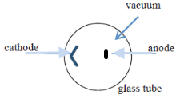
2017 Question 10 [Higher Level]
- Draw a labelled diagram of a photocell.
Anode, semi-cylindrical cathode, case, vacuum

- Describe how a photocell conducts current.
light of suitable frequency falls on cathode.
Electrons are emitted.

In practice it is connected up in a circuit as shown in the diagram underneath.

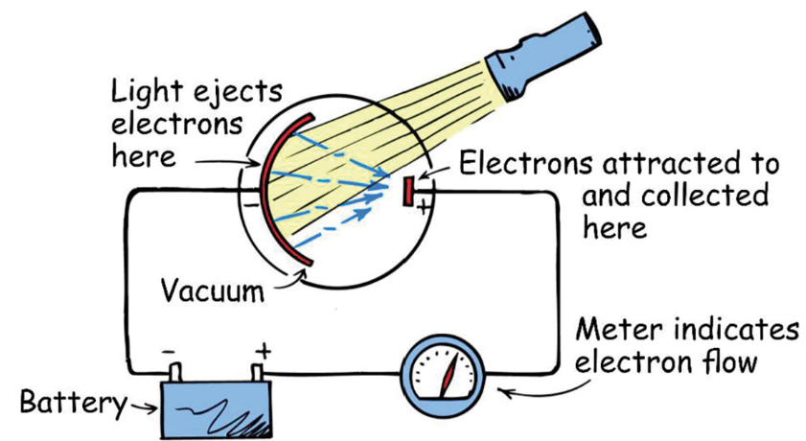
Operation
- Set up as shown

- Light of a suitable frequency shines on A (called the cathode or photocathode).
- This releases electrons (by the photoelectric effect).
- The electrons are attracted to point B (the anode), and from there they flow around the circuit, where they can be detected by a galvanometer, or alternatively they can be used to activate an electronic device.
- Note that if you bring the light source closer to the photocell there is now a greater intensity of light (more photons) falling on the cathode, which will result in the release of more electrons, as observed in a greater deflection in the galvanometer or ammeter.

Applications of photoelectric sensing devices
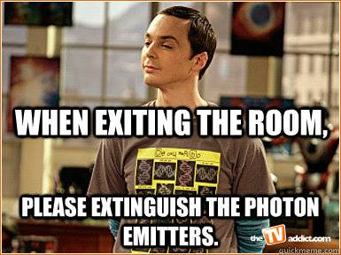
Automatic doors, photocopiers, light meters, solar panels

X-Rays

X-rays are produced when high-energy electrons collide with a high density target.
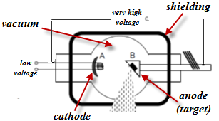

Operation of the X-ray tube
- The low voltage supplies power to a filament which in turn heats the cathode at A.
- Electrons are emitted from the hot cathode due to thermionic emission.
- They get accelerated across the vacuum due to the very high voltage and smash into the high-density anode (usually tungsten) at B.
- Most of the kinetic energy gets converted to heat, which must be removed with a coolant.
- Some inner electrons in the tungsten get bumped up to a high orbital, then quickly fall back down to a lower lever, emitting X-rays in the process.
- These X-rays are emitted in all directions.
- Most of these get absorbed by the lead shielding, but some exit through a narrow window, where they are then used for the required purpose.
Properties of X-Rays:
- They are electromagnetic waves
- They cause ionisation of atoms
- They have high penetration powers

Uses of X-rays
- Medicine: To detect broken bones - the X-rays pass through air and soft tissue but get absorbed by bone. This is why bones cast shadows on an X-ray film.
- Industry: To detect breaks in industrial pipes

Hazards
- They can ionise atoms in cells in the body, causing them to become abnormal, which can lead to cancer.

2023 Deferred Higher Level  What property of X‐rays makes them suitable for use in diagnosing a broken bone? | Answer  Penetrating ability
2020 Question 10 [Ordinary Level]  Why can X-ray production be considered as the inverse of the photoelectric effect? | X-ray production: electrons are used to produce electromagnetic radiation  The photoelectric effect: electromagnetic radiation is used to release electrons

X-Ray Maths questions

2015 Question 7 [Higher Level]
A potential difference of 50 kV is applied across an X-ray tube.
- Calculate the maximum velocity of an electron in the tube.
- Calculate the minimum wavelength of the X-rays produced by the tube.

Calculate the maximum velocity of an electron in the tube.
electrical potential energy at the beginning = kinetic energy of the electron at the end:
QV = ½ mv_{el}²

${vel}^{2}=\frac{2QV}{m}$ ${vel}^{2}=\frac{{(1.6 × 10}^{-19})(50000)}{{9.1× 10}^{-31}}$ $=1.69×{10}^{16}$ vel = 1.3 × 10⁸ m s^{–1}

Calculate the minimum wavelength of the X-rays produced by the tube.
In this case we assume that all of the potential energy at the beginning gets converted into X-rays (which are electromagnetic radiation) at the end.
The energy associated with electromagnetic radiation is given by E = hf.
Electrical potential energy at the beginning = electromagnetic energy at the end
QV = hf

We don’t know the frequency but do know the relationship between frequency and wavelength: c = fλ $f=\frac{c}{λ}$ So we have $QV=h\frac{c}{λ}$ $λ=\frac{ch}{QV}$

c = speed of light h = Planck’s constant Q = charge on an electron V = potential difference

$λ=\frac{{(3.0 × 10}^{8})({6.6 × 10}^{-34})}{({1.6 × 10}^{-19})(50000)}$ = 2.5 × 10^{–11} m

2010 Question 9 [Higher Level]
A potential difference (voltage) of 40 kV is applied across an X-ray tube.
- Calculate the maximum energy of an electron as it hits the target.
- Calculate the frequency of the most energetic X-ray produced.

- Calculate the maximum energy of an electron as it hits the target.
Q = .6 × 10⁻¹⁹ C V = 40 × 10³ V

W = QV
W = (1.6 × 10⁻¹⁹)( 40 × 10³)
W = 6.4 × 10⁻¹⁵ J

- Calculate the frequency of the most energetic X-ray produced.
E = hf $f=\frac{E}{h}= \frac{6.4 × {10}^{-15}}{6.6 × {10}^{-34}}$ f = 9.7 × 10¹⁸ Hz

2006 Question 12 (d) [Higher Level]
- Calculate the kinetic energy gained by an electron when it is accelerated through a potential difference of 50 kV in an X-ray tube.
- Calculate the minimum wavelength of an X-ray emitted from the anode.

- Calculate the kinetic energy gained by an electron
Kinetic energy at the end = Potential energy at the beginning
= (1.6 × 10⁻¹⁹)(50 × 10³)
= 8.0 × 10⁻¹⁵ J
- Calculate the minimum wavelength of an X-ray emitted from the anode.
E = hf $E=h\frac{c}{λ }$ $λ=\frac{hc}{E }$ $λ=\frac{(6.6 × {10}^{-34})(3.0 ×{10}^{8})}{8.0×{10}^{-15} }$ λ = 2.475 × 10⁻¹¹ m

2017 Question 10 [Higher Level]
A certain X-ray tube is designed to emit X-rays with wavelengths as small as 0.02 nm.
- Calculate the energy of an X-ray photon of wavelength 0.02 nm.
- Calculate the maximum velocity of an electron in the tube.
- Calculate the voltage applied to the electrons.

- A current of 2 μA is flowing in a photocell.
How many electrons are generated in the photocell during each minute?

- Calculate the energy of an X-ray photon of wavelength 0.02 nm
E= hf c = fλ E= h$\frac{c}{λ}$ E= [6.6 × 10⁻³⁴][$\frac{3.0 × {10}^{8}}{0.02 × {10}^{-9}}$]
E = 9.9 × 10⁻¹⁵ J
- Calculate the maximum velocity of an electron in the tube
E = ½mv²
9.9 × 10⁻¹⁵ = ½ (9.1× 10⁻³¹)(v)²
v = 1.48 × 10⁸ m s⁻¹

- Calculate the voltage applied to the electrons.
W = VQ $V=\frac{W}{q}$ $V=\frac{9.9 × {10}^{-15} }{1.6×{10}^{-19}}$ V = 62000V

- How many electrons are generated in the photocell during each minute?

Q = It = (2 × 10⁻⁶)(60) = 1.2 × 10⁻⁴ coulombs

1 electron = 1.6 × 10⁻¹⁹ coulombs

Number of electrons = $\frac{total charge}{charge of 1 electron}$ $= \frac{1.2 × {10}^{-4} }{1.6 × {10}^{-19}}$ = 7.5 × 10¹⁴ electrons

Extra reading

An introduction to quantum physics

The following is an extract from Michael Crichton’s science fiction book Timeline (pages 109 – 113 in the hardback version). It is a really cool account of how wonderful but crazy quantum physics is, and slap-bang in the middle is this scientific, but very readable version of light being a particle and a wave.
The narrator also discusses how this leads to a theory of multiple universes (and therefore making time-travel possible) – a theory which would have been scoffed at as recently as ten years ago, but which is now, amazingly, becoming more and more accepted by physicists as at least having some merit.

In fact, even when the narrator is discussing the accepted physics I’m convinced most readers would dismiss it as being too far fetched, and that the section is more ‘fiction’ than ‘science’.
What’s also amazing about this piece is that it includes some diagrams which could have come straight out of a university textbook – definitely not to be expected in a blockbuster science-fiction book;

################################# Beginning of extract ###################################

“Quantum mechanics?” Chris said. “What’s quantum mechanics?”
Gordon paused. “That’s fairly difficult. But since you’re historians,” he said, “let me try to explain it historically.”

“A hundred years ago,” Gordon said, “physicists understood that energy – like light or magnetism or electricity – took the form of continuously flowing waves. We still refer to ‘radio waves’ and ‘light waves’.
In fact the recognition that all forms of energy shared this wavelike nature behaviour was one of the great achievements of nineteenth-century physics.
“But there was a small problem,” he said.
It turned out that if you shined light on a metal plate, you got an electric current.
The physicist Max Planck studied the relationship between the amount of light shining on the plate and the amount of electricity produced, and he concluded that energy wasn’t a continuous wave.
Instead, energy seemed to be composed of individual units, which he called quanta. “The discovery that energy came in quanta was the start of quantum physics,” Gordon said.
“A few years later, Einstein showed that you could explain the photo-electric effect by assuming that light was composed of particles, which he called photons.
These photons of light struck the metal plate and knocked off electrons, producing electricity. Mathematically, the equations worked.
They fit the view that light consisted of particles. Okay so far?”
“Yes….”
“And pretty soon, physicists began to realise that not only light, but all energy was composed of particles. In fact, all matter in the universe took the form of particles. Atoms were composed of heavy particles in the nucleus, light electrons buzzing around on the outside.
So, according to the new thinking, everything is particles. Okay?”
“Okay….”
“The particles are discrete units, or quanta. And the theory that describes how these particles behave is quantum theory.
A major discovery of twentieth-century physics.”
They were all nodding.
“Physicists continue to study these particles, and began to realise they’re very strange entities.
You can’t predict where they are, you can’t measure them exactly, and you can’t predict what they will do.
Sometimes they will behave like particles, sometimes like waves.
Sometimes two particles will interact with each other even though they’re a million miles apart, with no connection between them.
And so on.
The theory is starting to seem extremely weird.
“Now, two things happen to quantum theory.
The first is that it gets confirmed, over and over.
It’s the most proven theory in the history of science.
Supermarket scanners, lasers and computer chips all rely on quantum mechanics.
So there is absolutely no doubt that quantum theory is the correct mathematical description of the universe.
“But the problem is, it’s only a mathematical description.
It’s just a set of equations.
And physicists couldn’t visualise the world that was implied by those equations – it was too weird, too contradictory.
Einstein, for one, didn’t like that. He felt it meant the theory was flawed.
But the theory kept getting confirmed, and the situation got worse and worse. Eventually even scientists who won the Nobel Prize for contributions to quantum theory had to admit they didn’t understand it.

################################# End of extract ###################################

Max Planck started the whole thing off, saying that heat was given off as little packets as opposed to continuous waves. Einstein took this a step further and suggested that perhaps light was also given off in little packets (called photons) instead of as a continuous wave. Planck, however, thought this was preposterous and could never accept Einstein’s idea. But Einstein also suffered a similar fate; predictability is one of the cornerstones of physics and resolving controversies in science usually involves successfully predicting the outcome of a specially-designed experiment. But it turns out that in nuclear physics an atomic nucleus breaks down into other, smaller nuclei, and predicting when this will occur is impossible.
The best we can do is to give the probability of a break-down occurring.
Einstein, whose own work formed the foundation for these ideas, could never accept these conclusions.
In fact one of his most famous quotes was on this subject: “God does not play dice”. What he meant by this is that the universe was not built around laws of probability (the reference to God was not meant to be taken literally – Einstein did not believe in a personal God).
For the record, all scientists now accept that probability does indeed lie at the heart of physics.

It gets better.
When formulating the rules for General Relativity – probably his greatest work of all – Einstein had assumed that the universe was static. i.e. it was not expanding. This was in keeping with the belief at the time. But one of the outcomes of General Relativity was that the universe was expanding. Believing that he had made a mistake somehow, he introduced a ‘fudge factor’ into his equations which stabilised the universe. When the deliberate error was later discovered (by a postgraduate student) Einstein described it as ‘the greatest mistake of my life’. By this stage the inflationary universe was becoming accepted as the correct description of the universe, which in turn implied that the ‘Big Bang’ did indeed occur.
One of the many ironies in all this is that it is now thought that the universe may not go on expanding forever, but may indeed either stabilise or begin to contract again, resulting in the universe finishing in a ‘Big Crunch’. Either way, Einstein’s fudge factor may not have been such a mistake after all.

Of course this was just when Einstein acknowledged he was wrong. He also made a bit of a serious boo-boo when it came to trying to unify the four forces of Nature. As a result of this he lost almost all respect among his peers, and spent the last decades of his career on a lone crusade which yielded nothing but the patronising sympathy of his fellow physicists. Interestingly, Einstein seems to have paid very little attention to developments in physics (including the discovery of all the new particles) during these latter years.
We will come across the concept of the four forces in more detail in the chapter on ‘Particle Physics’.

By the way, one of the biggest advocates of the ‘steady universe’ scenario was a scientist called Fred Hoyle. Hoyle died recently, but in yet another irony, actually coined the term ‘Big Bang’ as a means of showing how foolish the whole idea was.

So where does that leave us? Eventually there came an acceptance of this weirdness of light. It seemed that some phenomena could only be understood in terms of light being a wave, while other phenomena required it to be a particle. So the type of phenomenon being investigated determined whether you thought of light as a particle or a wave.


This is funny . . .

The electron as a wave – now that’s just taking the proverbial.

So now that we know that something which we thought was wave-like in nature can also be a particle, what happens if look again at something we know to be particle-like in nature? You can see where this is going.

The Thompson family
J.J. Thompson is the scientist credited with having ‘discovered’ electrons. He suggested that the streams of cathode rays were ‘negatively charged corpuscles’, and that these were smaller than the atoms of hydrogen.
He won a Nobel Prize for his work in 1906.
In 1927 J.J.’s son G.P. Thompson investigated the wave-like nature of electrons and was able to demonstrate that they diffract, and therefore must be considered as waves. He won a Nobel Prize for his work in 1937. So the father won a Nobel Prize for proving that the electron was a particle, while his son won the prize for proving that it was a wave. What has your family done lately?

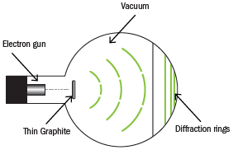
By the way, most school physics labs have a cathode ray tube of some description which we use to demonstrate the existence of these cathode rays. All we need to do to demonstrate the wavelike nature of elecrons is increase the potential difference between cathode and anode. It is a travesty to carry out the first demonstration and not continue on to the second (and possibly even more impressive) demonstration.
See demonstration here: https://youtu.be/UBiWBzG_BDs?t=570

Which reminds me of the story of the professor who began the new term with the following words:
“Right, today we're going to continue on with our lecture on the electron. Now who can remind us what an electron is?”
Hand goes up.
“It's am ... it's am, eh, am, oh I knew this before the break but I must have forgotten it.”
Professor: “That's just great, there are only two people in this world who can tell us what an electron is; we can't get in touch with the Creator, and you've just forgotten it.”
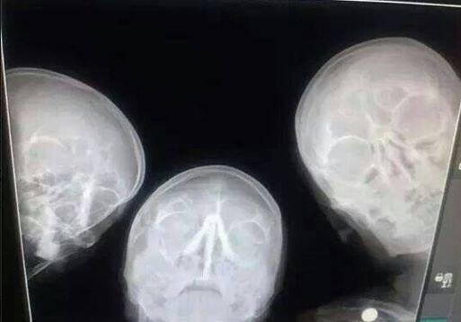

SLOP
Planck’s constant = 6.6 × 10⁻³⁴ J s speed of light = 3.0 × 10⁸ m s⁻¹
charge on electron = 1.6 × 10⁻¹⁹ C; mass of an electron = 9.1× 10⁻³¹ kg

The photoelectric effect
List two properties of the electron. | Negative charge, negligible mass , orbits nucleus, no internal structure, deflected by electric / magnetic field etc.
Name another subatomic particle. | Proton, neutron
Name the Irishman who gave the electron its name in the nineteenth century. | George Stoney
What is thermionic emission? | Thermionic emission is the emission of electrons from the surface of a hot metal.
Give two ways of deflecting a beam of electrons. | By means of an electric field and a magnetic field.
The cathode ray tube
What are cathode rays? | Cathode rays are streams of high speed electrons.
Give a use of a cathode ray tube. | Old-style televisions/ computer monitor, X-ray machine/oscilloscope /heart monitor/ECG.
How are electrons accelerated in a cathode ray tube? | By a high positive voltage between cathode and anode.
What happens when the electrons hit the screen? | Light is emitted (the screen fluoresces).
What happens to the energy of the electron when it hits the screen of the CRT? | The kinetic energy gets converted to light energy
What is thermionic emission? | It is the emission of electrons from the surface of a hot metal.
What is emitted from a metal surface when suitable light shines on the metal? | To attract and accelerate the beam of electrons.
Distinguish between photoelectric emission and thermionic emission. | Photoelectric effect: Emission of electrons when light of suitable frequency falls on a metal.  Thermionic emission: Emission of electrons from the surface of a hot metal.
Give two applications of the photoelectric effect. | Sound track in film, photography, counters, photocell, burglar alarm, automatic doors, etc.
What is a photon? | A photon is a packet of electromagnetic radiation.
Why as the quantum theory of light revolutionary? | Light has a particle nature (as well as a wave nature)
Describe an experiment to demonstrate the photoelectric effect. | Apparatus: gold leaf electroscope with zinc plate on top, ultraviolet light source  Procedure: Charge the electroscope negatively.  Shine ultraviolet light on the zinc plate.  Observation: The leaves fall together
Outline Einstein’s explanation of the photoelectric effect. | See notes
Write down an expression for Einstein’s photoelectric law. | hf = φ + ½mv²
A freshly cleaned piece of zinc metal is placed on the cap of a negatively charged gold leaf electroscope and illuminated with ultraviolet radiation.  Explain why the leaves of the electroscope collapse. | Photoelectric emission occurs (electrons get emitted from the surface of the metal).  The leaves become uncharged and therefore collapse.
Explain why the leaves do not collapse when the zinc is covered by a piece of ordinary glass. | Ordinary glass does absorbs UV light
Explain why the leaves do not collapse when the zinc is illuminated with green light. | The energy associated with photons of green light is too low for the photoelectric effect does not occur, so no electrons are emitted from the electroscope.
Explain why the leaves do not collapse when the electroscope is charged positively. | Any electrons emitted are attracted back to the positive electroscope.
In an experiment to demonstrate the photoelectric effect, a piece of zinc is placed on a gold leaf electroscope. The zinc is given a negative charge causing the gold leaf to deflect.  Explain why the gold leaf deflects when the zinc is given a negative charge. | Some of the excess electrons flow down to the bottom and the gold leaf moves away from the main section because similar charges repel.
Ultraviolet radiation is then shone on the charged zinc and the gold leaf falls.  Explain why. | Many electrons are emitted from the zinc as a result of the ultraviolet radiation shining on it. Electrons from the main part of the electroscope flow up to replace this so there aren’t as many electrons on the gold leaf to feel the repulsion.
What is observed when the experiment is repeated using infrared radiation? | Infrared radiation will not have sufficient energy to release electrons so the gold leaf will not diverge to begin with.
The photocell

The diagram shows a photocell connected in series with a sensitive galvanometer and a battery.  Name the parts labelled A and B. | A is the cathode  B is the anode
What happens at A when light falls on it? | Electrons are released
What happens in the circuit when the light falling on A gets brighter? | The current increases.
Give two applications of a photocell. | Burglar alarm, smoke alarms, safety switch, light meters, automatic lights, counters, automatic doors, control of central heating burners, sound track in films, scanner reading bar codes, stopping conveyer belt, solar cells etc.
X-rays

What are X-rays? | High frequency electromagnetic radiation.
Give three properties of X-rays | Electromagnetic waves / have short wavelength, ionise, penetrate, no mass, no charge, effect photographic film, cause fluorescence, diffraction, etc.
How do X-rays differ from light rays? | X-rays penetrate matter / cause ionization; light rays don’t.
Give three uses of X-rays. | To photograph bones/ internal organs, to treat cancer, to detect flaws in materials.
Draw a labelled diagram of an X-ray tube. | See notes. Your diagram should contain a filament, cathode, high voltage, anode, target, lead shielding, reference to vacuum.
How are X-rays produced? | Accelerated (fast moving) electrons strike a (heavy) metal target causing electrons in the target to rise to a high orbital level. When these electrons fall back down to a lower lever they emit they energy as X-rays.
How are the electrons emitted from the cathode? | The electrons are emitted from the cathode due to thermionic emission because the filament is hot.
How are the electrons accelerated? | By the high voltage between the anode and cathode.
What is the function of the high voltage across the X-ray tube? | To accelerate the electrons.
Name a suitable material for the target in the X-ray tube. | Tungsten
What happens when the electrons hit the target? | Some inner electrons in the tungsten target get bumped up to a high orbital, then quickly fall back down to a lower lever, emitting X-rays in the process.
Why is a lead-shield normally put around an X-ray tube? | For protection (to prevent X-rays entering the body).
When electrons hit the target in an X-ray tube, only a small percentage of their energy is converted into X-rays. What happens to the rest of their energy? | The energy gets converted to heat.
How does this influence the type of target used? | The target material must have a very high melting point.
Give one safety precaution when using X-rays. | Use a lead shield, lead apron, lead glass, monitor dosage.
Justify the statement “X-ray production may be considered as the inverse of the photoelectric effect.” | X-ray: Electrons in, electromagnetic radiation is emitted.  Photoelectric: electromagnetic radiation in and electrons are emitted.

The electron exam questions 2002 - 2023
Higher and Ordinary Level

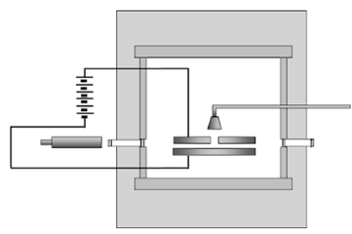
The Millikan oil drop experiment

2021 Question 13 [Ordinary Level]
Read the following passage and answer the questions below.
The Millikan Oil Drop Experiment
An experiment performed by Robert Millikan in 1909 determined the size of the charge on an electron. He also determined that there was a smallest unit charge. He received the Nobel Prize for his work.

The experiment Millikan performed involved putting a charge on a tiny drop of oil using X‐rays and measuring how strong an applied electric field had to be in order to stop the oil drop from falling.
By attaching a battery to the plates above and below the chamber, Millikan was able to apply an electric voltage. The electric field produced in the chamber by this voltage would act on the charged oil drop.
If the voltage was just right, the electromagnetic force would just balance the force of gravity on a drop, and the drop would hang suspended in mid‐air.
Using a microscope, he measured the radius of the drop. Given that the density of the oil was known, Millikan could calculate the mass of each oil drop. Using this mass, he could calculate the weight of one drop. He could then determine the electric charge on the drop.
By varying the charge on different drops, he noticed that the charge was always a multiple of 1.6 × 10⁻¹⁹ C, the charge on a single electron.
Adapted from ffden‐2.phys.uaf.edu/212_fall2003.web.dir/ryan_mcallister

  - What did Millikan determine with his 1909 oil drop experiment?
  - What is the size of the charge on one electron?
  - X‐rays are made by accelerating electrons across an X‐ray tube. How are the electrons produced in an X‐ray tube?
  - A drop has a volume of 2.03 × 10⁻¹⁷ m³ and a density of 886 kg m⁻³. Calculate the mass of the drop.
  - Draw the circuit symbol for a battery.
  - In the oil drop experiment, Millikan applied an electric field between the plates until the drop no longer moved up or down. What is an electric field?
  - Sketch the electric field that is formed between two oppositely charged parallel plates.
  - Show the forces acting on the drop when it is not moving up or down.

2016 Question 12 (b) [Higher Level]
In 1909 Robert Millikan determined the charge on an electron by experiment.
A tiny drop of oil was placed between two horizontal plates, one directly above the other as shown. The oil drop was ionised by X-rays so that it became negatively charged. An electric field was applied between the plates until the drop no longer moved up or down.

- Define electric field strength.
- In your answer book, sketch the electric field pattern between two oppositely charged parallel plates.
- Draw a diagram to show the forces acting on the drop of oil when it is stationary.
- The electric field strength between the plates was 3.6 × 10⁴ V m^{–1} when the drop of oil was stationary, and the mass of the drop was 2.4 × 10^{–15} kg.
Calculate the charge of the drop.
- How many excess electrons are on this drop?
(acceleration due to gravity = 9.8 m s^{–2})

Cathode ray tube – Ordinary level

2002 Question 6 [Ordinary Level]
- What is thermionic emission?
- The diagram shows a simple cathode ray tube.
- Name the parts labelled A, B, C and D in the diagram.
- Give the function of any two of these parts.
- How can the beam of electrons be deflected?
- Give a use of a cathode ray tube.
- In an X-ray tube, electrons are also produced by thermionic emission.
- Draw a sketch of an X-ray tube.
- Why is a lead-shield normally put around an X-ray tube?

2005 Question 10 [Ordinary Level]
- The electron is one of the three main subatomic particles.
Give two properties of the electron.
- Name another subatomic particle.
- The diagram shows a simple cathode ray tube.
Name the parts labelled A, B and C.
- Electrons are emitted from A, accelerated across the tube and strike the screen.
Explain how the electrons are emitted from A.
- What causes the electrons to be accelerated across the tube?
- What happens when the electrons hit the screen?
- How can a beam of electrons be deflected?
- Give one use of a cathode ray tube.

2009 Question 12 (d) [Ordinary Level]
- The diagram shows a simple cathode ray tube. Thermionic emission occurs at plate A.
- What is thermionic emission?
- What are cathode rays?
- Why is there a high voltage between A and B?
- What happens to the cathode rays when they hit the screen C?
- Give a use for a cathode ray tube.

2023 Question 12 [Ordinary level]
An electron is a negatively charged subatomic particle.
- Name a positively charged subatomic particle.
- Name a neutral subatomic particle.
- Draw a labelled diagram of an atom. Include in your diagram the names and locations of the subatomic particles of the atom.
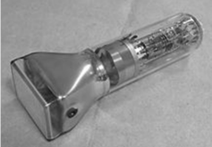
The picture on the right is of a cathode ray tube. A beam of electrons is produced in a cathode ray tube.
- How are the electrons produced in a cathode ray tube?
- How can the beam of electrons be deflected in a cathode ray tube?
- How is the beam of electrons detected in a cathode ray tube?

2012 Question 10 [Ordinary Level]
A cathode ray tube and an X-ray tube are practical applications of thermionic emission.
In these tubes thermionic emission releases electrons, which are then accelerated into a beam.
An electron is a subatomic particle.
- Name another subatomic particle and give two of its properties.
- The diagram shows a simple cathode ray tube.
Name the parts labelled A, B, C.
- Give the function of any two of these labelled parts.
- How can the beam of electrons be deflected?
- What happens at C when the electrons hit it?
- Why is a vacuum needed in a cathode ray tube?
- In an X-ray tube, a beam of electrons is used to produce X-rays.
Draw a sketch of an X-ray tube.
- Give one safety precaution taken by a radiographer when using an X-ray machine.

2016 Question 10 [Ordinary Level]
X-ray tubes and cathode ray tubes are practical applications of thermionic emission.
Thermionic emission causes the emission of electrons, which are sub-atomic particles.
The diagram shows a simple cathode ray tube, which produces a beam of electrons by thermionic emission.

- State two properties of the electron. Name another sub-atomic particle.
- Name the parts labelled A, B, and C in the diagram.
- State the function of any two of these parts.
- How could the beam of electrons be deflected?
- Why is it important to have a vacuum inside a cathode ray tube?
- State one use of a cathode ray tube.
- Electrons are produced by thermionic emission in an X-ray tube also.
Draw a sketch of an X-ray tube.
- Why are lead aprons often worn when using an X-ray tube?

Cathode ray tube – Higher level
2003 Question 9 [Higher Level]
- List two properties of the electron.
- Name the Irishman who gave the electron its name in the nineteenth century.
- Give an expression for the force acting on a charge q moving at a velocity v at right angles to a magnetic field of flux density B.
- An electron is emitted from the cathode and accelerated through a potential difference of 4kV in a cathode ray tube (CRT) as shown in the diagram.
How much energy does the electron gain?
- What is the speed of the electron at the anode? (Assume that the speed of the electron leaving the cathode is negligible.)
- After leaving the anode, the electron travels at a constant speed and enters a magnetic field at right angles, where it is deflected. The flux density of the magnetic field is 5 × 10^{–2} T.
Calculate the force acting on the electron.
- Calculate the radius of the circular path followed by the electron, in the magnetic field.
- What happens to the energy of the electron when it hits the screen of the CRT?
mass of electron = 9.1 × 10^{–31} kg; charge on electron = 1.6 × 10^{–19} C

The photoelectric effect / the photocell Ordinary level

201l Question 11 [Ordinary Level]
Read this passage and answer the questions below.
Einstein explained the photoelectric effect by using Planck’s quantum theory (E=hf).
The German physicist Heinrich Hertz in 1887 was the first to discover that when light shines on certain metals, they emit electrons.

Metals have the property that some of their electrons are only loosely bound within atoms, which is why they are such good conductors of electricity. When light strikes a metallic surface it transfers its energy to the metal, in the same way as when light shines on your skin, causing you to feel warmer. This transfer of energy from the light can agitate electrons in the metal, and some of the loosely bound electrons can be knocked off the surface of the metal.

But the strange features of the photoelectric effect become apparent when one studies the more detailed properties of the released electrons. As the intensity of the light – its brightness – is increased the number of released electrons will also increase, but their speed stays the same. On the other hand, the speed of the released electrons will increase if the frequency of the light shining on the metal is increased.
(Adapted from ‘Elegant Universe' by Brian Greene, Vintage 2000)

  - Who discovered the photoelectric effect?
  - Who explained the photoelectric effect?
  - What happens when light shines on certain metals?
  - Why is a metal a good conductor of electricity?
  - Why does your skin feel warm when light shines on it?
  - In the photoelectric effect, what happens when the intensity of the light is increased?
  - How can the speed of electrons emitted in the photoelectric effect be controlled?
  - Give one application of the photoelectric effect.

2006 Question 12 (c) [Ordinary Level]
- In an experiment to demonstrate the photoelectric effect, a piece of zinc is placed on a gold leaf electroscope, as shown. The zinc is given a negative charge causing the gold leaf to deflect.
Explain why the gold leaf deflects when the zinc is given a negative charge.
- Ultraviolet radiation is then shone on the charged zinc and the gold leaf falls.
Explain why.
- What is observed when the experiment is repeated using infrared radiation?
- Give one application of the photoelectric effect.

2003 Question 12 (d) [Ordinary Level]
- What is a photon?
- The diagram shows a photocell connected in series with a sensitive galvanometer and a battery. Name the parts labelled A and B.
- What happens at A when light falls on it?
- What happens in the circuit when the light falling on A gets brighter?
- Give an application of a photocell.

2008 Question 12 (c) [Ordinary Level]
- What is the photoelectric effect?
- A photocell is connected to a sensitive galvanometer as shown in the diagram.
- When light from the torch falls on the photocell, a current is detected by the galvanometer.
- Name the parts of the photocell labelled A and B.
- How can you vary the brightness of the light falling on the photocell?
- How does the brightness of the light effect the current?
- Give a use for a photocell.

The photoelectric effect / the photocell Higher level

2005 Question 12 (d) [Higher Level]
- One hundred years ago, Albert Einstein explained the photoelectric effect.
What is the photoelectric effect?
- Write down an expression for Einstein’s photoelectric law.
- Summarise Einstein’s explanation of the photoelectric effect.
- Give one application of the photoelectric effect.

2022 Question 14 (c) [Higher level]
The explanation of the photoelectric effect by Albert Einstein led to the quantum revolution in physics.
- Describe a laboratory experiment to demonstrate the photoelectric effect.
- Light of wavelength 450 nm is incident on a metal that has a work function of 2.4 eV.
Calculate the maximum speed of the emitted electrons.
- It is observed that as the wavelength of the incident light increases, the speed of the emitted electrons decreases and eventually no electrons are emitted.
Explain these observations.

2004 Question 9 [Higher Level]
- Distinguish between photoelectric emission and thermionic emission.
- A freshly cleaned piece of zinc metal is placed on the cap of a negatively charged gold leaf electroscope and illuminated with ultraviolet radiation.
Explain why the leaves of the electroscope collapse.
- Explain why the leaves do not collapse when the zinc is covered by a piece of ordinary glass.
- Explain why the leaves do not collapse when the zinc is illuminated with green light.
- Explain why the leaves do not collapse when the electroscope is charged positively.
- The zinc metal is illuminated with ultraviolet light of wavelength 240 nm. The work function of zinc is 4.3 eV.
Calculate the threshold frequency of zinc.
- Calculate the maximum kinetic energy of an emitted electron.
Planck’s constant = 6.6 × 10^{–34} J s; speed of light = 3.0 × 10⁸ m s^{–1}; 1 eV = 1.6 × 10^{–19} J

2009 Question 8 [Higher Level]
- An investigation was carried out to establish the relationship between the current flowing in a photocell and the frequency of the light incident on it. The graph illustrates the relationship.
Draw a labelled diagram of the structure of a photocell.
- Using the graph, calculate the work function of the metal.
- What is the maximum speed of an emitted electron when light of wavelength 550 nm is incident on the photocell?
- Explain why a current does not flow in the photocell when the frequency of the light is less than 5.2 × 10¹⁴ Hz.
The relationship between the current flowing in a photocell and the intensity of the light incident on the photocell was then investigated. Readings were taken and a graph was drawn to show the relationship.
- Draw a sketch of the graph obtained.
- How was the intensity of the light varied?
- What conclusion about the nature of light can be drawn from these investigations?

(Planck constant = 6.6 × 10^{–34} J s; speed of light = 3.0 × 10⁸ m s^{–1};
charge on electron = 1.6 × 10^{–19} C; mass of electron = 9.1 × 10^{–31} kg)

2004 Question 12 (d) [Higher Level]
A typical solar panel consists of a sandwich made of a p‐n junction surrounded by a pair of conductors. When light falls on the solar panel, the photoelectric effect occurs and a current flows.

- What is a p‐n junction?
- In 1921, Albert Einstein was awarded the Nobel Prize in Physics for his explanation of the photoelectric effect.
Outline his explanation.
- The work function of iron is 4.7 eV.
Calculate the maximum kinetic energy of an emitted electron when ultraviolet radiation of wavelength 200 nm is incident on iron.

Question 14 (d) Higher Level 2023
- Distinguish between thermionic emission and the photoelectric effect.
- Describe a laboratory experiment to demonstrate the photoelectric effect.
- Electrons of maximum velocity 0.023c are emitted when electromagnetic radiation is incident on a zinc metal plate. Zinc has a work function of 4.3 eV.
Calculate the frequency of the incident radiation.

2012 Question 12 (d) [Higher Level]
- Draw a diagram to show the structure of a photocell.
- Describe an experiment to demonstrate how the current through a photocell can be increased.
- Give an application of the photoelectric effect.

The dual nature of light
2016 Question 11 [Higher Level]
Read the following passage and answer the accompanying questions.
The story of theories of light nicely demonstrates the ways in which theories are used as science evolves. Some ideas are discarded while others are retained as approximations that are appropriate in certain circumstances.
Geometrical optics hit its heyday in the nineteenth century when the Irish mathematician William Rowan Hamilton made a mathematical prediction about conical refraction that was later verified by his friend and colleague Humphrey Lloyd.
Geometrical optics, though clearly an approximation, is nonetheless a good description for a wave with wavelengths small enough for interference effects to be irrelevant. Ray diagrams can be used to explain refraction and reflection as well as in the fields of photography, medicine and astronomy.
Isaac Newton had developed a ‘corpuscular’ theory that was inconsistent with the wave theory of light developed by his rival Robert Hooke and by Christian Huygens. Thomas Young measured light interference, providing a clear verification that light had the properties of a wave.
However, later developments in quantum theory demonstrated that Newton was also correct in some sense. Quantum mechanics now tells us that light is indeed composed of individual particles called photons that are responsible for communicating the electromagnetic force. Quantum mechanics gives us our most fundamental description of what light is and how it interacts with matter.

(Adapted from Knocking on Heaven’s Door: How Physics and Scientific Thinking Illuminate the Universe and the Modern World, Lisa Randall, Random House, 2011)

- State the laws of refraction.
- Draw a ray diagram to show the formation of a virtual image in a magnifying glass.
- Explain what is meant by the term wavelength.
- As part of his investigations into light, Newton dispersed light with a prism.
List the colours observed by Newton, in order, starting with the colour that was refracted the least.
- In Young’s experiment to demonstrate the wave nature of light he needed two coherent sources of light. How might he have produced these sources?
- Calculate the energy of a photon of green light, which has a wavelength of 510 nm.
- Quantum mechanics is used to explain how electrons in atoms produce line emission spectra.
Describe how these spectra are produced.
- State two differences between photons and electrons.

2017 Question 9 {middle 2 parts} [Higher Level]
- One of his students, Niels Bohr, further developed Rutherford’s model of the atom.
The Bohr model helps us identify different elements using emission line spectra.
Explain, using the Bohr model, how line spectra are formed.
- Draw a labelled diagram of a spectrometer and describe how a spectrometer and diffraction grating can be used to observe (i) a line spectrum and (ii) a continuous spectrum.

X-Rays Ordinary level
2018 Question 10 [Ordinary Level]
X‐rays are produced when a beam of high speed electrons collides with a target in a tube like the one shown.
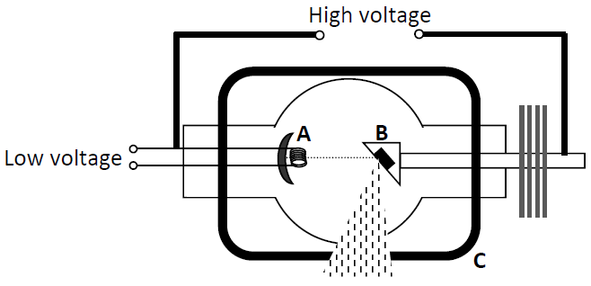
  - What are X‐rays? State two properties of X‐rays.
  - What process occurs at part A?
  - Name a substance used in part B.
  - State the function of part C.
  - State one use of X‐rays.
  - Why is a vacuum needed inside an X‐ray tube?
  - Name another device that uses a beam of high speed electrons.
  - State one use for the device you have named in part (vii).
  - State one difference between X‐rays and gamma‐rays.

2004 Question 12 (d) [Ordinary Level]
- The diagram shows an X-ray tube.
What are X-rays?
- How are electrons emitted from the cathode C?
- What is the function of the high voltage across the X-ray tube?
- Name a suitable material for the target T in the X-ray tube.
- Give one use of X-rays.

2007 Question 10 [Ordinary Level]
X-rays were discovered by Wilhelm Röntgen in 1895.
- What are X-rays?
- Give one use for X-rays.
- The diagram shows a simple X-ray tube.
Name the parts labelled A, B and C.
- Electrons are emitted from A, accelerated across the tube and strike B. Explain how the electrons are emitted from A.
- What is the purpose of the high voltage supply?
- What happens when the electrons hit part B?
- Name a suitable material to use for part B.
- Give one safety precaution when using X-rays.

2013 Question 10 [Ordinary Level]
- X-rays are used to diagnose and treat medical conditions.
The image shows an X-ray photograph.
What are X-rays?
- State a property of X-rays that makes them suitable for medical use.
- Give a use, other than medical, for X-rays.
- In an X-ray tube a beam of electrons is used to produce X-rays.
Draw a labelled diagram showing the main parts of an X-ray tube.
- How are electrons produced in an X-ray tube?
- What is the purpose of the high voltage in an X-ray tube?
- What happens when the electrons hit the target in an X-ray tube?
- Name a suitable material for use as the target.
- Give one safety precaution required when using X-rays.

2015 Question 10 [Ordinary Level]
X-rays are produced when a beam of high speed electrons collides with a target in an X-ray tube, as shown below.
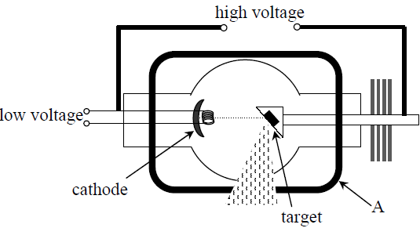
- What are X-rays?
- State two properties of X-rays.
- What process occurs at the cathode?
- Name a substance commonly used as the target.
- State the function of the part marked A.
- State one use of X-rays.
- A cathode ray tube, like the one used in the cathode ray oscilloscope, also uses a beam of high speed electrons.
Draw a sketch of a cathode ray tube suitable for use in an oscilloscope.
- Why is a vacuum needed in both the X-ray tube and the cathode ray tube?
- State one use of a cathode ray oscilloscope.

2023 Question 12 [Ordinary level]
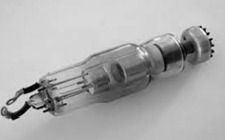
- The picture on the right is of an X-ray tube. A beam of high speed electrons is used to produce X-rays in an X-ray tube.
How are the electrons accelerated to high speeds in an X-ray tube?

Tungsten is often used as the target in an X-ray tube because it has a high melting point.
- Why does the target in an X-ray tube need to have a high melting point?
- X-rays are a type of electromagnetic radiation. They travel at a speed of 3 × 10⁸ m s⁻¹.
Calculate the wavelength of an X-ray that has a frequency of 5.5 × 10¹⁷ Hz.
- Name one other type of electromagnetic radiation.

X-Rays Higher level
Question 10 Higher Level 2023
- A voltage of 70 kV is applied across an X‐ray tube.
Calculate the maximum speed of the electrons produced in the tube.
- Draw a labelled diagram of an X‐ray tube.

2010 Question 9 [Higher Level]
- What is thermionic emission?
- X-rays are produced when high-energy electrons collide with a target.
Draw a labelled diagram of an X-ray tube.
- What are X-rays?
- How do they differ from light rays?
- Give two uses of X-rays.
- When electrons hit the target in an X-ray tube, only a small percentage of their energy is converted into X-rays. What happens to the rest of their energy.
- How does this influence the type of target used?
- A potential difference (voltage) of 40 kV is applied across an X-ray tube.
Calculate the maximum energy of an electron as it hits the target.
- Calculate the frequency of the most energetic X-ray produced.

2006 Question 12 (d) [Higher Level]
The first Nobel Prize in Physics was awarded in 1901 for the discovery of X-rays.
- What are X-rays?
- Who discovered them?
In an X-ray tube electrons are emitted from a metal cathode and accelerated across the tube to hit a metal anode.
- How are the electrons emitted from the cathode?
- How are the electrons accelerated?
- Calculate the kinetic energy gained by an electron when it is accelerated through a potential difference of 50 kV in an X-ray tube.
- Calculate the minimum wavelength of an X-ray emitted from the anode.
Planck constant = 6.6 × 10^{–34} J s; speed of light = 3.0 × 10⁸ m s^{–1}; charge on electron = 1.6 × 10^{–19} C

X-Rays and the photoelectric effect

2010 Question 10 [Ordinary Level]
X-rays are produced when high speed electrons collide with a target in an X-ray tube as shown in the diagram.
- What process occurs at the filament A?
- Name a substance commonly used as the target B
- Give three properties of X-rays
- Give two uses of X-rays
- State the function of the part marked C
- The photoelectric effect can be regarded as the inverse of X-ray production.
- Describe an experiment to demonstrate the photoelectric effect
- Give two applications of the photoelectric effect

2020 Question 10 [Ordinary Level]
Irish physicist G.J. Stoney named the electron in 1891. J.J. Thomson identified it as a particle in 1897.
- Where in the atom is the electron found?
- Compare the mass of an electron to the mass of a proton.
- Electrons are produced in a cathode ray tube by thermionic emission.
What is meant by thermionic emission?
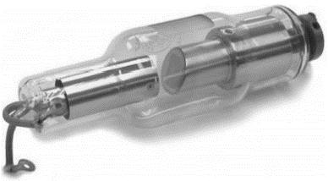
- Draw a labelled diagram of a cathode ray tube.
- How are the electrons detected in a cathode ray tube?
- State one use of a cathode ray tube.
- The photoelectric effect is the emission of electrons from the surface of a metal when light of a suitable frequency falls on it.
Describe an experiment to demonstrate the photoelectric effect.
- The picture shows an X‐ray tube. What is an X‐ray?
- Explain why the production of X‐rays can be considered to be the opposite of the photoelectric effect.
State one danger associated with X‐rays.

2015 Question 7 [Higher Level]
X-rays have two important uses in medicine: imaging and radiation therapy.

- Describe, with the aid of a labelled diagram of an X-ray tube, how X-rays are produced.

A potential difference of 50 kV is applied across an X-ray tube.
- Calculate the maximum velocity of an electron in the tube.
- Calculate the minimum wavelength of the X-rays produced by the tube.

The large atoms found in bones (e.g. calcium and phosphorus) absorb X-ray photons.
The small atoms found in soft tissue (e.g. carbon and hydrogen) do not absorb X-ray photons. This is why bones cast shadows on an X-ray film.
The X-ray photons absorbed by large atoms can cause the photoelectric effect to occur.

- What is the photoelectric effect?
- Describe a laboratory experiment to demonstrate the photoelectric effect.

- Albert Einstein received a Nobel Prize in 1921 for his explanation of the photoelectric effect.
Outline Einstein’s explanation of the photoelectric effect.

2017 Question 10 [Higher Level]
- What are X-rays?

Electrons are produced and used in an X-ray tube.
- How are the electrons produced?
- Where in the tube does this take place?

A certain X-ray tube is designed to emit X-rays with wavelengths as small as 0.02 nm.
- Calculate the energy of an X-ray photon of wavelength 0.02 nm
- Calculate the maximum velocity of an electron in the tube
- Calculate the voltage applied to the electrons.

Electrons are also produced and used in a photocell.
- Draw a labelled diagram of a photocell.
- Describe how a photocell conducts current.
- A current of 2 μA is flowing in a photocell.
How many electrons are generated in the photocell during each minute?

2022 Question 12 [Ordinary Level]
The Irish physicist George Stoney is most famous for introducing the term electron.
- State two properties of the electron.
- The photoelectric effect is the release of electrons from the surface of a metal when light of a suitable frequency falls on it.
Describe an experiment to demonstrate the photoelectric effect.
- To ensure the photoelectric effect occurs, the light must be of a suitable frequency to release the electrons.
The frequency of the light must be above the threshold frequency.
Describe what happens if the frequency of the incident light is below the threshold frequency.
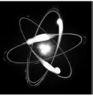
The threshold frequency for zinc is 6.5 × 10¹⁴ Hz.
- Calculate the wavelength of light of this frequency.
- Calculate the energy of a photon of this frequency.

X–ray production is the inverse process of the photoelectric effect.
In an X–ray tube, X–rays are produced when high speed electrons hit a target.
- How are electrons produced in an X–ray tube?
- How are electrons accelerated in an X–ray tube?

Tungsten is often used as the target in an X–ray tube.
- State one property of tungsten that makes it suitable to use as the target.
- What material could be used to ensure that the X–rays do not escape from the X–ray tube?

2002 Question 9 [Higher Level]
- Explain with the aid of a labelled diagram how X-rays are produced.
- Justify the statement “X-ray production may be considered as the inverse of the photoelectric effect.”
- Describe an experiment to demonstrate the photoelectric effect.
- Outline Einstein’s explanation of the photoelectric effect.
- Give two applications of a photocell.

2021 Question 14 (c) [Higher Level]
In the photoelectric effect electrons are emitted from the surface of a metal when the incoming light of intensity I has a frequency f that exceeds a certain value f_{o}, the threshold frequency.
Describe what happens when
- f > fo , f is constant and I is increasing,
- f > fo , f is increasing and I is constant,
- f < fo , f is constant and I is increasing.

Light of wavelength 440 nm is incident on a metal that has a work function of 2.6 eV.
- Calculate the threshold frequency of the metal.
- Calculate the maximum speed of the emitted electrons.


2022 Deferred Question 10 [Higher Level]
(a) The photograph shows a flat‐screen television set.
Flat‐screen displays have replaced cathode ray tubes in most applications.
- Explain, with the aid of a labelled diagram, the operation of a cathode ray tube.
- State two of the disadvantages of cathode ray tubes that led to their replacement by flat‐screen displays.

(b) The photocell is based on the photoelectric effect.
- What information does the photoelectric effect give about the nature of light?
- What effect does the frequency of the incident light have on the current flowing in a photocell?
- Describe how you would show this effect in the laboratory.
- What effect does the intensity of the incident light have on the current flowing in a photocell?
- Describe how you would show this effect in the laboratory.
- Light of frequency 7.6 × 10¹⁴ Hz is incident on a metal that has a work function of 2.1 eV.
- Calculate the energy of a photon of the incident light,
- Calculate the energy of the most energetic electron emitted.

Structure of the atom and emission spectrums Higher Level

2022 Deferred Question 8 [Higher Level]
- What is meant by the emission line spectrum of an element?
- How is the emission line spectrum of an element related to the energy levels of the electrons in an atom of that element?
- Describe how you would show the emission line spectrum of hydrogen in the laboratory.

2020 Question 11 [Higher level]
- Describe with the aid of a labelled diagram the Bohr model of the atom. Use the model to explain emission line spectra.

2: Semiconductors

Introduction
The (semiconductor) diode is probably the most significant development of the 20th century. Semiconductor diodes are the building blocks of transistors and these transistos are in turn the main component of the microprocessor chip which is found in every electronic device in your house. Today’s microprocessor chips can contain over one billion transistors with 10 km of metal interconnections all on a chip the size of a pea.

No semiconductor diode = no transistor = no computers, no internet, no dubious websites . . .

Student Notes
A semiconductor is a material whose resistivity is between that of a good conductor and a good insulator.

Note that you must use the word ‘resistivity’ and not ‘resistance’ in the definition above.

Examples of materials which are semiconductors are silicon and germanium.

The resistance of a sample of a semiconductor decreases as its temperature increases.

Electrons gain energy as a result of thermal agitation (jiggly atoms) and they break the bonds that were keeping them attached to a particular atom. They now become available for conduction. These electrons are now available for conduction and so resistance decreases.

This ‘liberation’ of electrons can also be caused by light shining on the material.

Negative electrons and positive holes
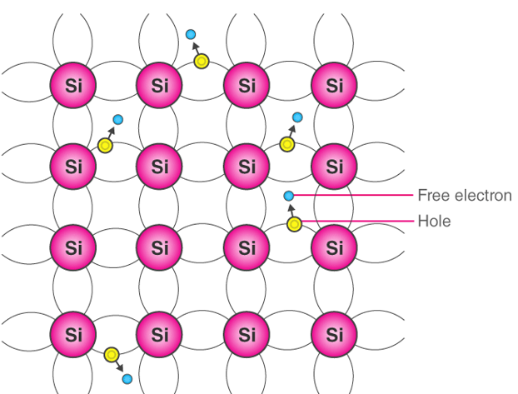
If a particular electron gains energy and leaves an atom it leaves a ‘space’ behind. This electron is now mobile and may quickly end up beside another atom which also has a space associated with it due to the same thing happening there.
If the first electron ‘drops into’ that space and fills it, we could talk about the electron going from atom 1 to atom 2, or we could say that the space itself ‘moved’ from atom 2 to atom 1.
Every time the electron goes in one direction, the space obviously ‘goes’ the other way, so if an electron moves towards a positive charge, the space will ‘move away’ from that charge. It is as though the space is positively charged. Not being blessed with wild imaginations, physicists called this space a ‘positive hole’. And even though we know that the positive hole isn’t actually a ‘thing’ as you Gen Z folk all say, we pretend that it is because it simplifies the explanation for much of what follows.
Intrinsic conduction is the movement of charges through a pure semiconductor with equal number of electrons & holes.

Movement of electrons and holes in a semiconductor material

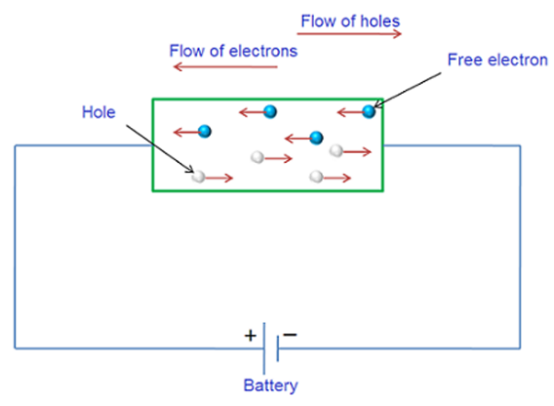

Thermistors and LDRs

A thermistor is an electrical component whose resistance decreases rapidly with increasing temperature
Thermistor | Symbol
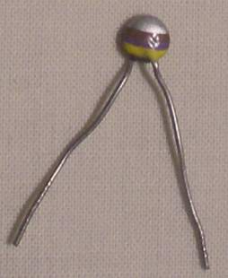

A light dependant resistor (LDR) is an electrical component whose resistance decreases rapidly when light shines on it.
LDR | Symbol
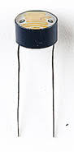 | 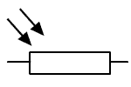

Doping
You know how doping is used by some athletes to increase their performance? Same goes for semiconductors.
Doping is the addition of a small amount of atoms of another element to a pure semiconductor to increase its conductivity.
Extrinsic conduction is the movement of charges through a doped semiconductor with an unequal number of electrons and holes.
We can inject the pure silicon semiconductor with atoms of phosphorus in which case we end up with one electron per atom which is free to move about the entire substance and so the overall conductivity increases.

Alternatively we can inject the pure silicon semiconductor with atoms of boron in which case we end up with one hole per atom which is free to move about the entire substance and so the overall conductivity increases.

An n-type semiconductor is a semiconductor in which electrons are the majority charge carriers.  Put in phosporos in the center | A p-type semiconductor is a semiconductor in which holes are the majority charge carriers.
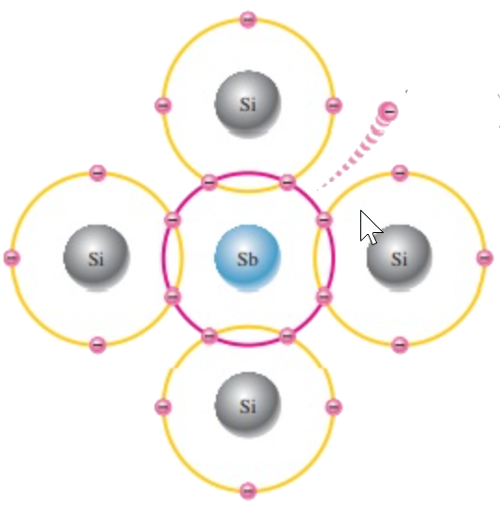 | 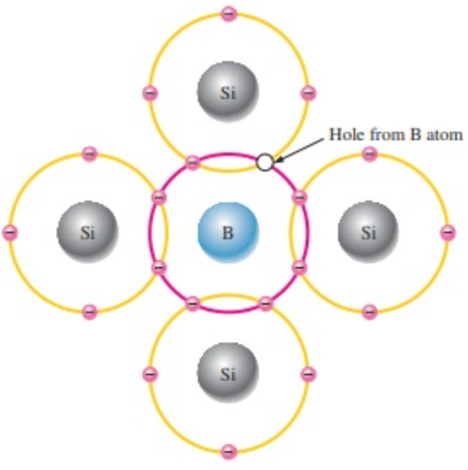

Why semiconductors are so powerful: The p-n junction

The p-n junction*
When a piece of p-type semiconductor is joined to a piece of n-type semiconductor, the junction between the two is known as a p-n junction.

How a depletion region is formed

The depletion region is so named because it is formed from a conducting region of the semiconductor which has been depleted of all free charge carriers. You need to know how this is created.

- Due to thermal agitation, some free electrons in the n-type material diffuse over to the p-type material, where they combine with nearby positive holes, with the result that the region is depleted of two of its charge carriers.
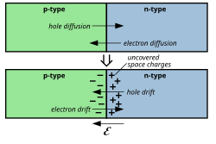
- Similarly on the p-type side some positive holes diffuse over to the n-type material, where they too combine with nearby electrons, with the result that the region gets depleted of two more of its charge carriers.
- The end result is that a depletion region is formed at the junction of the p-type and n-type materials, where there are no free charge carriers. This region therefore acts as an insulator.

- Work now needs to be done to bring charge from one side of this depletion region to the other; therefore a potential difference (voltage) exists across the region.
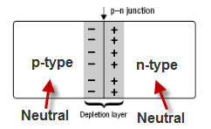
- This voltage is typically about 0.1 volts for a germanium diode, and 0.6 volts for a silicon diode.
- This voltage is known as the junction voltage.
Exam question: Can you explain the why the charge distribution is as indicated on the second diagram?

Current flow across a p-n junction

Forward-biased p-n junction
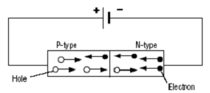
- Here the positive terminal of the junction is connected to the p-type and the negative terminal is connected to the n-type.
- Electrons in the N-type area above are repelled from the negative terminal and drive in to the depletion region.
- Similarly positive holes in the P-type are repelled from the positive terminal and drive into the depletion region from the other side.
- The end result is that the width of the depletion layer is reduced.
- In fact if the voltage across the terminals is sufficiently great (greater than what is known as the junction voltage) the depletion layer is completely broken down and the region now becomes a conductor.

Reversed-biased p-n junction
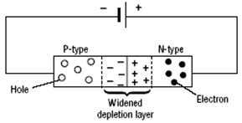
- Here the positive terminal of the junction is connected to the n-type and the negative terminal is connected to the p-type.
- Electrons in the N-type area above are now attracted to the positive terminal and because as a result the depletion region in this section grows bigger.
- Similarly positive holes in the P-type are attracted to the negative terminal.
- The end result is that the width of the depletion layer is increased.
- The end result is that no charges actually move through the depletion region and it remains an insulator.
A (semiconductor) diode will only allow current to flow in one direction
Image | Symbol
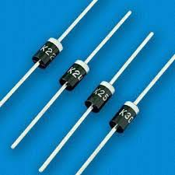 | 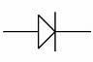
Current will only be able to flow if it is moving in the same direction as the arrow (see symbol). The silver strip at the end of the actual diode indicates that that is the ‘pointed’ end.

Graph of current against voltage for a semiconductor diode

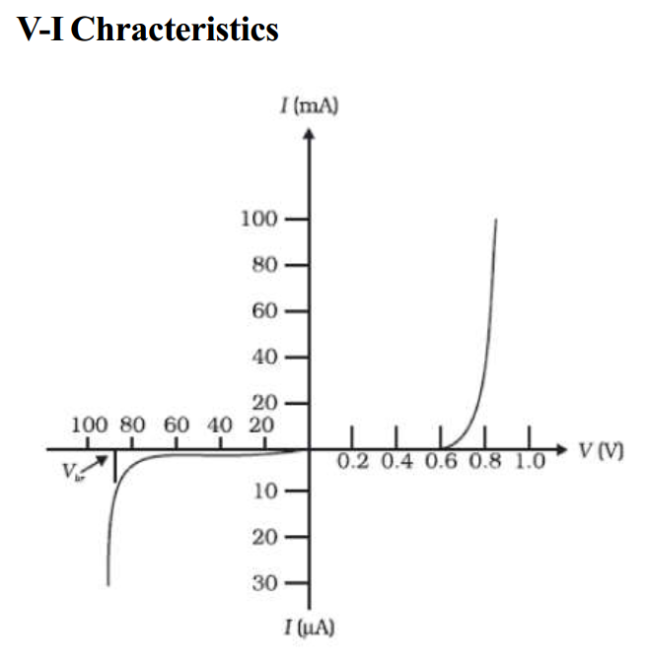

- The right hand side of the graph represents the p-n junction in forward bias
- Note that in forward bias very little current flows until the voltage reaches 0.6 volts (junction voltage).
- At this stage the depletion layer gets completely broken down and the region now becomes a conductor, and therefore the current rises suddenly.
- The left hand side of the graph represents the p-n junction in reverse bias and little or no current flows unless we pass 100 volt through it. I’ve no idea what happens at that stage other than the diode gets destroyed.

A rectifier is a device that uses diodes to convert a.c. to d.c
Examples of appliances that contain a rectifier:
Radio, television, computer, battery charger, mobile phone charger.

Demonstrating the action of a diode

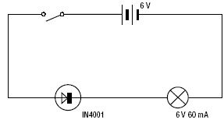
- Use a light bulb in series with the semiconductor and the battery.
- Close the switch.
- The bulb will light up if the diode is orientated as shown (it is forward biased) but not if the diode is turned the other way around (reverse biased).

The light-emitting diode (LED)

An LED is an electrical device which emits light from the pn junction when it is forward biased
Image | Symbol
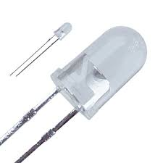 | 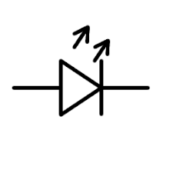

Question: What do a call a part-time band leader?
Answer: A semi-conductor!
Boom Boom!!!

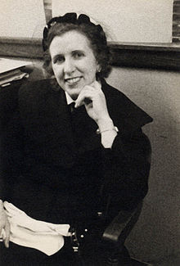
1946: The world's 1st general-purpose computer was called the ENIAC. It had 6 programmers (all mathematicians), one of whom was from Co. Donegal - Kay McNulty! In fact the term ‘computer’ originally referred to the programmers, not the machines.
McNulty used the ENIAC to compute artillery ballistic trajectories for the US Army.

TO INVESTIGATE THE VARIATION OF RESISTANCE OF A THERMISTOR WITH TEMPERATURE

APPARATUS:
Thermistor, glycerol, beaker, heat source, thermometer, ohmmeter, boiling tube

DIAGRAM:
PROCEDURE:
1. Set up the apparatus as shown in the diagram.

2. Use the thermometer to note the temperature of the glycerol, which we assume to be the same as the temperature of the thermistor.

3. Record the resistance of the thermistor using the ohmmeter.

4. Heat the beaker and for each 10 °C rise in temperature record the resistance and temperature using the ohmmeter and the thermometer.

5. Plot a graph of resistance against temperature.

RESULTS:
R (Ω)
θ (⁰C)
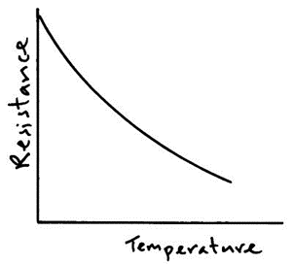
CONCLUSION:
- From the graph we can see that as temperature increases the resistance decreases.
- We believe our data to be reliable because it resulted in a smooth curve, which the theory predicted.

PRECAUTIONS / SOURCES OF ERROR:
- Check for the resistance of the connecting leads and contacts on the ohmmeter. Subtract from later readings.
- Heat very slowly to try to maintain thermal equilibrium between the water and glycerol and thermistor. When the bunsen is removed wait until the temperature is steady before taking the resistance readings.
- Use glycerol in the test tube as it is a better heat conductor than water.

Exam questions
OL: 2013, 2009, 2002 HL: 2010

      - [2009 OL][2013 OL]
In an experiment to investigate the variation of the resistance R of a thermistor with its temperature θ, a student measured the resistance of the thermistor at different temperatures.
The table shows the measurements recorded by the student.
θ/ ⁰C | 20 | 30 | 40 | 50 | 60 | 70 | 80
R/Ω | 2000 | 1300 | 800 | 400 | 200 | 90 | 40

- Draw a labelled diagram of the apparatus used in this experiment.
- How did the student measure the resistance of the thermistor?
- Plot a graph on graph paper to show the relationship between the resistance R of the thermistor and its temperature θ (put θ on the X-axis).
- Use your graph to estimate the temperature of the thermistor when its resistance is 1000 Ω.
- What does your graph tell you about the relationship between the resistance of a thermistor and its temperature?

      - [2002 OL]
The circuit diagram shows a thermistor connected to a meter M.
/ ⁰C | 20 | 30 | 40 | 50 | 60 | 70 | 80 | 90
R/ Ω | 1300 | 900 | 640 | 460 | 340 | 260 | 200 | 150
A student used the circuit to measure the resistance R of the thermistor at different temperatures θ.

- Name the meter M used to measure the resistance of the thermistor.
- Explain, with the aid of a labelled diagram, how the student varied the temperature of the thermistor.
- How did the student measure the temperature of the thermistor?
- The table shows the measurements recorded by the student.
Draw a graph on graph paper of resistance R against temperature θ. Put temperature on the horizontal axis.
- Using your graph, estimate the temperature of the thermistor when the meter M read 740 Ω.

- [2010]
In an experiment to investigate the variation of the resistance R of a thermistor with its temperature θ, a student measured its resistance at different temperatures.
θ /°C | 20 | 30 | 40 | 50 | 60 | 70 | 80
R/Ω | 2000 | 1300 | 800 | 400 | 200 | 90 | 40
The table shows the measurements recorded.

- Draw a labelled diagram of the apparatus used.
- How was the resistance measured?
- Describe how the temperature was varied.
- Using the recorded data, plot a graph to show the variation of the resistance of a thermistor with its temperature.
- Use your graph to estimate the average variation of resistance per Kelvin in the range 45 °C – 55 °C.
- In this investigation, why is the thermistor usually immersed in oil rather than in water?

Worked solutions

[2009 OL][2013 OL]
- Draw a labelled diagram of the apparatus used in this experiment.
See diagram
- How did the student measure the resistance of the thermistor?
Using an ohmmeter as shown
- Plot a graph on graph paper to show the relationship
See graph
- Use your graph to estimate the temperature of the thermistor when its resistance is 1000 Ω.
35 ⁰C to 36.5⁰ C
- What does your graph tell you about the relationship between the resistance of a thermistor and its temperature?
Resistance goes down with increased temperature and the relationship is not linear.

[2002 OL]
- Name the meter M used to measure the resistance of the thermistor.
Ohmmeter
- Explain, with the aid of a labelled diagram, how the student varied the temperature of the thermistor.
The apparatus was placed over a hot plate which heated the water and then the glycerol and the thermistor.
- How did the student measure the temperature of the thermistor?
Using a thermometer.
- Draw a graph on graph paper of resistance R against temperature θ.
See graph
- Using your graph, estimate the temperature of the thermistor when the meter M read 740 Ω.
35 ⁰C.

[2010]
- Draw a labelled diagram of the apparatus used.
Thermistor, thermometer in waterbath/oil, thermistor connected to labelled ohmmeter/(digital) multimeter
- How was the resistance measured?
The thermistor is connected to the ohmmeter and the value of the resistance was read from the ohmmeter.
- Describe how the temperature was varied.
By allowing the apparatus to heat up over a bunsen burner.
- Using the recorded data, plot a graph to show the variation of the resistance of a thermistor with its temperature.
Label axes correctly on graph paper
Plot six points correctly
Smooth curve
Good distribution
- Use your graph to estimate the average variation of resistance per Kelvin in the range 45 °C – 55 °C.
Range: 28↔ 32 Ω (⁰C^{–1}) or Ω (K^{–1})
- In this investigation, why is the thermistor usually immersed in oil rather than in water?
Oil is a better conductor of heat / water contains air / (impure) water conducts electricity/good thermal contact

TO INVESTIGATE THE VARIATION OF CURRENT WITH POTENTIAL DIFFERENCE FOR A SEMICONDUCTOR DIODE

(i) Semiconductor diode in forward bias

APPARATUS:
Low voltage power supply, rheostat, voltmeter, ammeter, 330 Ω resistor, semiconductor diode

DIAGRAM:
PROCEDURE:
1. Set up the circuit with the semiconductor diode in forward bias as shown.

2. Adjust the potential divider to obtain different values for the voltage V and hence for the current I.

3. Obtain at least ten values for V and for I using the voltmeter and the ammeter.

4. Plot a graph of I against V and join the points in a smooth, continuous curve.

RESULTS:

V (volts)
I (milliamps)

CONCLUSION:
We can see from the graph that almost no current flows until the applied voltage exceeds 0.6 V for a silicon diode but then the current rises rapidly.

NOTE:
A protective resistor, e.g. 330 Ω, should always be used in series with a diode in forward bias. Therefore even if the diode offers no resistance there will still be some other resistance in the circuit preventing the current getting too high.

A germanium diode, e.g. OA91, gives very little current between 0 and 0.2 V but the current then increases rapidly above this voltage.
A light emitting diode gives very little current up to 1.6 V but then the current rises rapidly accompanied by the emission of light.

(ii) Semiconductor diode in reverse bias

APPARATUS:
Low voltage power supply, rheostat, voltmeter, ammeter, semiconductor diode.
DIAGRAM:

PROCEDURE:
- Set up the circuit as above and set the voltage supply at 20 V.

- The micro-ammeter is used in this part of the experiment, as current values will be very low when a diode is in reverse bias.

- Adjust the potential divider to obtain different values for the voltage V and hence for the current I.

- Obtain at least six values for V (0-20 V) and for I using the voltmeter and the micro-ammeter. Higher voltage values are required for conduction in reverse bias.

- Plot a graph of I against V and join the points in a smooth, continuous curve.

RESULTS:

V (volts)
I (microamps)

CONCLUSION:
We found no current in reverse bias. In theory there should be a very small amount of current but it was too small to be detected with our equipment.

PRECAUTIONS / SOURCES OF ERROR:
- Use a microammeter when the diode is reverse biased as the current flowing is extremely small.

- Change the positions of the microammeter and voltmeter (reverse biased) so that the current flowing through the diode is the only one registered in the microammeter (not current through the voltmeter)

NOTES:
The position of the voltmeter has changed since a reverse biased diode has a very large resistance that is greater than the resistance of most voltmeters. It is essential that the micro-ammeter reads only the current flowing through the reverse biased diode as the sum of the currents flowing through the voltmeter and reverse biased diode may be much larger.
Since the resistance of the micro-ammeter is negligible compared with the resistance of the reverse biased diode the potential difference across the micro-ammeter and diode is almost the same as the potential difference across the diode alone.

Using a potentiometer
Better to use a potentiometer to control the voltage because you can get it to go from 0 to max volts wherease rheostats change from low to high but you may not be able to get a sufficiently low voltage for this experiment.

When using a silicon diode it is very difficult to detect the current in reverse bias as the current is so small and changes very little with temperature variations.
For a germanium diode some reverse current can be detected (a few μA) at 4 V reverse bias. This conduction increases rapidly when the diode is heated (by hand).
It is difficult to detect any current for silicon diodes when reverse -biased so for this reason the germanium OA91 is recommended.
Related Exam Questions
OL: 2008 HL: 2019, 2012, 2007

[2008 OL]
The diagram shows a circuit used to investigate the variation of current with potential difference for a semiconductor diode in forward bias.
- Name the apparatus X. What does it measure?
- Name the apparatus Y. What does it do?
- What is the function of the 330 Ω resistor in this circuit?
potential difference/V | 0 | 0.2 | 0.4 | 0.6 | 0.8 | 1.0
current/mA | 0 | 3 | 6 | 14 | 50 | 100
- The table shows the values of the potential difference used and its corresponding current recorded during the experiment.
Using the data in the table, draw a graph on graph paper of the current against the potential difference.
Put potential difference on the horizontal axis (X-axis).
- What does the graph tell you about the variation of current with potential difference for a semiconductor diode?

[2019]
In an experiment to investigate the variation of current I with potential difference V for a semiconductor diode the following data were recorded.
V (mV) | 0 | 50 | 100 | 150 | 200 | 250 | 300
I (mA) | 0 | 0 | 0 | 2 | 5 | 40 | 110

- Draw a circuit diagram for this experiment.
- Use the data to draw a graph of current against potential difference.
- Use your graph to determine the junction voltage.
- What happened in the diode when the junction voltage was exceeded?
- Is Ohm’s law obeyed for the diode? Justify your answer.
- The diode is now reversed and data is recorded.
State two other changes that are made to the circuit before recording data for a diode in reverse bias.

[2012]
The following is part of a student’s report on an experiment to investigate the variation of the current I with potential difference V for a semiconductor diode.
V/V | 0 | 0.50 | 0.59 | 0.65 | 0.68 | 0.70 | 0.72
I/mA | 0 | 3.0 | 5.4 | 11.7 | 17.4 | 27.3 | 36.5

- Draw a circuit diagram used by the student.
- How did the student vary and measure the potential difference?
- Using the data, draw a graph to show how the current varies with the potential difference for the semiconductor diode.
Does the resistance of the diode remain constant during the investigation?
- Justify your answer.
- The student continued the experiment with the connections to the semiconductor diode reversed.
What adjustments should be made to the circuit to obtain valid readings?

Worked solutions

[2008 OL]
- Name the apparatus X. What does it measure?
Ammeter. It measures amps.
- Name the apparatus Y. What does it do?
Rheostat / variable resistor / potential divider
It changes the resistance which in turn changes the voltage.
- What is the function of the 330 Ω resistor in this circuit?
It protects the diode by limiting the current.
- Using the data in the table, draw a graph on graph paper of the current against the potential difference.
See graph
- What does the graph tell you about the variation of current with potential difference for a semiconductor diode?
They are not proportional because the current rises rapidly after the potential difference reaches 0.6 V.

[2019]
- Draw a circuit diagram for this experiment.
See notes: source of varying voltage, diode, ammeter, voltmeter
- Use the data to draw a graph of current against potential difference.
labelled axes
points plotted
curve of good fit
- Use your graph to determine the junction voltage.
≈ 0.2 V
- What happened in the diode when the junction voltage was exceeded?
The depletion layer broke down and current flows
- Is Ohm’s law obeyed for the diode? Justify your answer.
No. Not a straight line through the origin.
- State two other changes that are made to the circuit before recording data for a diode in reverse bias.
Replace ammeter with a microammeter,
Place voltmeter across diode and (micro)ammeter

[2012]
- Draw a circuit diagram used by the student.
- apparatus: p.s.u., ammeter, voltmeter, diode
- correct arrangement
- diode in forward bias
- How did the student vary and measure the potential difference?
Vary using rheostat /variable resistor / dial on (variable) p.s.u.
Measure p.d. from voltmeter (across diode – stated or implied)
- Using the data, draw a graph to show how the current varies with the potential difference for the semiconductor diode.
See graph
- Does the resistance of the diode remain constant during the investigation?
Justify your answer.
No
I is not proportional to V or equivalent, e.g. ‘graph is not a straight line through origin’.
- What adjustments should be made to the circuit to obtain valid readings?
microammeter used (instead of ammeter/milliammeter) // voltmeter placed across diode and microammeter, etc.

SLOP
What is a semiconductor? | A semiconductor is a material whose resistivity is between that of a conductor and insulator.
Name a material used in the manufacture of semiconductors. | Silicon, germanium
Why is silicon a semiconductor? | It has a resistivity between that of a conductor and an insulator.
Give one difference between conduction in metals and conduction in semiconductors. | There are two types of charge carriers (holes and electrons) in semiconductors, whereas with metals electrons are the only charge carriers.  Conduction increases with temperature for semiconductors whereas conduction decreases with temperature for metals.
As the temperature of a room increases, explain why the resistance of a thermistor decreases. | More energy is added to the thermistor therefore more electrons are released and are available for conduction.
Give two uses of semiconductors. | Rectifiers, transistors, diodes, thermistors, thermometers, radios/TV, etc.
Give a use for a thermistor. | Thermometer, heat sensor, temperature control.
What is doping? | Doping is the addition of a small amount of atoms of another element to a pure semiconductor to increase its conductivity.
Distinguish between intrinsic conduction and extrinsic conduction in a semiconductor. | Intrinsic conduction occurs in a pure semiconductor and involves an equal number of electrons and (positive) holes.  Extrinsic conduction occurs in a doped semiconductor where either the electrons or the positive holes are the majority charge carriers.
Semiconductors can be made p-type or n-type. How is a semiconductor made p-type? | By doping it with Boron.
Explain how the presence of phosphorus and boron makes silicon a better conductor. | When phosphorus is added more electrons become available as charge carriers.  When boron is added more positive holes become available as charge carriers.
Give one difference between a p-type semiconductor and an n-type semiconductor. | P-type material contains more holes than n-type material.  N-type material contains more free electrons than p-type material.
What are the charge carriers when an electric current passes through a semiconductor? | Electrons and (positive) holes
What is a p-n junction? | A p-n junction is the region connecting the p-type semiconductor to the n-type semiconductor
Draw a diagram showing a p-n junction connected in forward bias to a d.c. supply. | See diagram
What happens at the boundary of the two adjacent layers?. | Electrons and holes cross the junction cancelling each other out and recombine and as a result there are no free charge carriers.  A depletion layer is therefore formed between the n-type and p-type regions and as a result a junction voltage is created.
Explain how a depletion layer is formed at the junction. | Electrons from n-type and holes from p-type cross the junction and recombine cancelling each other out and as a result there are no free charge carriers across this narrow insulating region.  A depletion layer is therefore formed which now acts as a ‘barrier’ between the n-type and p-type regions and as a result a junction voltage is created.
Describe what happens at the boundary when the semiconductor diode is forward biased. | The depletion layer breaks down and the diode conducts.
Describe what happens at the boundary when the semiconductor diode is reverse biased. | The width of depletion layer gets increased and the region acts as an insulator.
Why does the p-n junction become a good conductor as the potential difference exceeds 0.6 volts? | The depletion layer is overcome and as a result a large current flows.
Sketch a graph to show the variation of current with potential difference for a semiconductor diode in forward bias. | See diagram
Explain, using the graph, how the current varies with the potential difference for a p-n junction in forward bias. | Very little current flows between 0 V and 0.6 V  If the potential difference is greater than 0.6 V a large current flows.
What is a diode? | A diode is a device that allows current to flow in one direction only.
Give a use of a semiconductor diode. | A rectifier
Give an example of a device that contains a rectifier. | Radio, television, computer, battery charger, mobile phone charger.
Draw the symbol for an light emitting diode

Draw the symbol for a thermistor

Draw the symbol for a diode

Draw the symbol for a LDR

Electron Band Structure in Germanium - my ass
Abstract
The exponential dependence of resistivity on temperature in germanium is found to be a great big lie.
My careful theoretical modelling and painstaking experimentation reveal that:
- My equipment is crap, as are all the available texts on the subject and
- That this whole exercise was a complete waste of my time.

Introduction
Electrons in germanium are confined to well-defined energy bands that are separated by "forbidden regions" of zero charge-carrier density.
You can read about it yourself if you want to, although I don't recommend it.
You'll have to wade through an obtuse, convoluted discussion about considering an arbitrary number of non-coupled harmonic-oscillator potentials and taking limits and so on.
The upshot is that if you heat up a sample of germanium, electrons will jump from a non-conductive energy band to a conductive one, thereby creating a measurable change in resistivity.
This relation between temperature and resistivity can be shown to be exponential in certain temperature regimes by waving your hands and chanting "to first order".

Experiment procedure
I sifted through the box of germanium crystals and chose the one that appeared to be the least cracked.
Then I soldered wires onto the crystal in the spots shown in figure 2b of Lab Handout 32.
Do you have any idea how hard it is to solder wires to germanium?
I'll tell you: real goddamn hard.
The solder simply won't stick, and you can forget about getting any of the grad students in the solid state labs to help you out.
Once the wires were in place, I attached them as appropriate to the second-rate equipment I scavenged from the back of the lab, none of which worked properly.
I soon wised up and swiped replacements from the well-stocked research labs.
This is how they treat undergrads around here: they give you broken tools and then don't understand why you don't get any results.

In order to control the temperature of the germanium, I attached the crystal to a copper rod, the upper end of which was attached to a heating coil and the lower end of which was dipped in a thermos of liquid nitrogen.
Midway through the project, the thermos began leaking.
That's right: I pay a cool ten grand a quarter to come here, and yet they can't spare the five bucks to ensure that I have a working thermos.
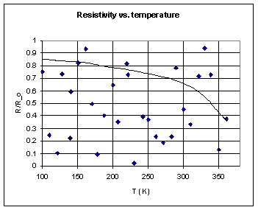
Fig. 1: Check this shit out.

Results
Check this shit out (Fig. 1). That's bonafide, 100%-real data, my friends.
I took it myself over the course of two weeks.
And this was not a leisurely two weeks, either; I busted my ass day and night in order to provide you with nothing but the best data possible.
Now, let's look a bit more closely at this data, remembering that it is absolutely first-rate.
Do you see the exponential dependence?
I sure don't.
I see a bunch of crap.
Christ, this was such a waste of my time.
Banking on my hopes that whoever grades this will just look at the pictures, I drew an exponential through my noise.
I believe the apparent legitimacy is enhanced by the fact that I used a complicated computer program to make the fit.
I understand this is the same process by which the top quark was discovered.

Conclusion
Going into physics was the biggest mistake of my life - I should've declared Computer Science.

Taken from http://www.cs.wisc.edu/~kovar/hall.html

Semiconductor exam questions 2002 - 2022

Ordinary Level
2009 Question 12 (c) [Ordinary Level]
A p-n junction (diode) is formed by doping adjacent layers of a semiconductor.
A depletion layer is formed at their junction.
- Explain the underlined terms.
- How is a depletion layer formed?
- The diagram shows two diodes connected to two bulbs A and B, a 6 V supply and a switch. What is observed when the switch is closed?
- Explain why this happens.

2006 Question 12 (d) [Ordinary Level]
- A semiconductor material can be doped to form a p-n junction.
Explain the underlined terms.
- Name a material used as a semiconductor.
- The circuit diagram shows 2 semiconductor diodes and 2 bulbs, labelled A and B,connected to a 6 V d.c. supply.
What is observed when the switch is closed?
- Explain why

2003 Question 11 [Ordinary Level]
Read the following passage and answer the accompanying questions.
The operation of semiconductor devices depends on the effects that occur when p-type and n-type semiconductor material are in close contact. This is achieved by taking a single crystal of silicon and doping separate but adjacent layers of it with suitable impurities. The junction between the p-type and the n-type layers is referred to as the p–n junction and this is the key to some very important aspects of semiconductor theory.
Devices such as diodes, transistors, silicon-controlled rectifiers, etc., all contain one or more p–n junctions.
(“Physics – a teacher’s handbook”, Dept. of Education and Science.)
(a) What is a semiconductor?
(b) Name a material used in the manufacture of semiconductors.
(c) Name the two types of charge carriers in semiconductors.
(d) What is meant by doping?
(e) Give one difference between a p-type semiconductor and an n-type semiconductor.
(f) What is a p-n junction?
(g) What is a diode?
(h) Give an example of a device that contains a rectifier.

Higher Level

2009 Question 12 (b) [Higher Level]
A semiconductor diode is formed when small quantities of phosphorus and boron are added to adjacent layers of a crystal of silicon to increase its conduction.
- Explain how the presence of phosphorus and boron makes the silicon a better conductor.
- What happens at the boundary of the two adjacent layers?
- Describe what happens at the boundary when the semiconductor diode is forward biased
- Describe what happens at the boundary when the semiconductor diode is reverse biased.
- Give a use of a semiconductor diode.

2004 Question 12 (d) [Higher Level]
- A p-n junction is formed by taking a single crystal of silicon and doping separate but adjacent layers of it. A depletion layer is formed at the junction.
What is doping?
- Explain how a depletion layer is formed at the junction.
- The graph shows the variation of current I with potential difference V for a p-n junction in forward bias.
Explain, using the graph, how the current varies with the potential difference.
- Why does the p-n junction become a good conductor as the potential difference exceeds 0.6 Volts?

2016 Question 8 [Higher Level]
- What is a semiconductor?
- Distinguish between intrinsic and extrinsic conduction in a semiconductor.
- Explain how a pure semiconductor can be converted into (i) a p-type and (ii) an n-type semiconductor.
- A semiconductor p-n junction acts a diode.
Describe, with the aid of a labelled diagram, how a depletion layer is formed at the p-n junction.
- What is a depletion layer?
- Indicate on your diagram the sections of the p-n junction that are positively charged, negatively charged and neutral.

- A diode will be damaged if too large a current flows through it when it is connected in forward bias. Explain how a diode might be protected from having too large a current flowing through it when it is connected across a battery, as in the diagram.
- What would be the effect on the current flowing in this diode if the terminals of the battery were reversed? Explain your answer.
- A diode can be used as a rectifier. What is the function of a rectifier?
- What property of a diode makes it useful in a rectifier circuit?

2019 Question 12 (b) [Higher Level]
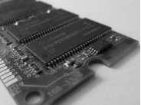
A RAM (random access memory) integrated chip contains transistors, in which there are doped semiconductors, and capacitors.
- What is a semiconductor?
- What is meant by doping a semiconductor?
- How can a semiconductor be doped so that its majority charge carriers are electrons?
- How can a semiconductor be doped so that its majority charge carriers are holes?

The capacitance of a capacitor in a RAM chip is 90 fF. It operates at a voltage of 1.2 V.
- Calculate the energy stored in the capacitor when it is fully charged.
- Calculate the number of additional electrons that are on the negative plate of the capacitor as a result of it being fully charged.

2022 Question 8 [Higher level]
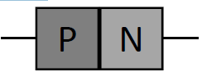
Semiconductors are essential in many electrical devices.

- Distinguish between conductors, insulators and semiconductors.
- Semiconductors can be converted into p-type semiconductors and n-type semiconductors by doping.
A p-n junction is used in a diode. What is meant by doping?
- How does p-type doping differ from n-type doping?
- A depletion layer exists in a p-n junction.
Describe a depletion layer and explain how it forms.
- Indicate on a diagram the sections of a p-n junction that are positively charged, negatively charged and neutral.
- Associated with every diode is a voltage called its junction voltage. When a variable voltage is applied across a diode held in forward bias, the depletion layer breaks down as the junction voltage is reached.
Draw a circuit diagram to show this arrangement.
- Sketch a graph to show the variation of current with voltage for this arrangement.
Indicate the junction voltage on your graph.
- In many electric circuits a resistor is placed in series with a diode. Explain why this may be necessary.

2022 Deferred Question 11 [Higher Level]
An LDR is a light dependent resistor.
It can be used in a circuit to monitor the intensity (brightness) of light.
- Describe an experiment to show how the resistance of an LDR varies with the intensity of the light falling on it.
- Sketch a graph to show the relationship between the resistance of an LDR and the intensity of the light falling on it.

Mind you the term ‘orbits’ comes from an outdated model of the structure of the atom. Chemistry teachers tend to go apoplectic when they hear that physics teachers still talk about orbits. Which is as good a reason as any to keep using it if you ask me.
This was used to investigate electrons (before anyone knew what an electron was). What was known was that if a fluorescent screen was placed on the inside of the tube to the right of the anode, fluorescence would occur. Therefore something seemed to be coming from the cathode. Because the electrons could not be seen directly, this ‘something’ was called cathode rays, and the apparatus was called a cathode ray tube. Incidentally, the cathode ray tube was first developed by Sir William Crookes. Crooke was a major player in the world of physics in the late 19th century but later lost all respectability amongst his peers due to his willingness to get involved in psychic research (being able to read someone else’s mind and all that).
The joule is a very large unit of energy relative to the energies involved at the atomic level, so physicists wanted to come up with a much smaller unit. After much deliberation, scratching of baldy heads and picking at patches on corduroy jackets, they decided the electron-volt was the right man for the job.
There was one major problem with Rutherford’s picture of the atom. If the electrons were moving in a circular path then the maths suggested that they should be losing energy and therefore would very quickly spiral into the nucleus. And this wasn’t happening.
Neils Bohr Bohr was raised in a middle class Danish family and showed no particular talent as a child except for sports. He played soccer at close to professional level and was an active skier until late in his life. His brother Harald won a silver medal in the first Olympic soccer competition.
We have already encountered this equation in the previous chapter on the electron.
Each element has its own unique emission spectrum (you could say that they have their very own barcode). This is how Celia Payne-Gaposchkin first realised that the sun is mainly hydrogen and helium. In fact helium was discovered on the sun before it was discovered on Earth, hence the name (from Helios - the Greek Sun god).
You need to use the term ‘electromagnetic radiation’ rather than ‘light’. ’Light’ implies just visible light but and we need to include a much more broad range of frequencies, hence the term ‘electromagnetic radiation’.
"I therefore take the liberty of proposing for this hypothetical new atom, which is not light but plays an essential part in every process of radiation, the name photon." Gilbert N. Lewis, 1926. Einstein’s was later awarded a Nobel Prize for his work on the photoelectric effect.
And not we move on as if there’s nothing more to say. We can’t have you leaving the class thinking that physics might actually be interesting.
So to sum up what we know so far; light is a wave and we can prove this via Young’s double slit experiment. Light is made up of particles called photons and we can prove this via the photoelectric effect. And light cannot be both – that option was investigated and discarded early on. So what are we left with? Well one of the big players of this era was William Bragg. He had to lecture to students in college and was once asked by a journalist whether he considered light to be a particle or a wave. He replied, "Physicists use the wave theory on Mondays, Wednesdays and Fridays, and the particle theory on Tuesdays, Thursdays and Saturdays." See below for extracts from one of Einstein’s famous paper on the photoelectric effect, written in 1905 “The body’s surface layer is penetrated by energy quanta whose energy is converted at least partially into kinetic energy of the electrons.The simplest conception is that a light quantum transfers its entire energy to a single electron.” According to the assumption considered here, when a light ray starting from a point is propagated, the energy is not continuously distributed over an ever increasing volume, but it consists of a finite number of energy quanta, localised in space, which move without being divided and which can be absorbed or emitted only as a whole. Analogy of the photoelectric effect The energy of the incident photon is like the money in your pocket at the start of a night out The work function energy is analogous to the admission charge at the nightclub. It's an all or nothing thing, even if you're only just one penny short, you will be refused entrance. Different clubs may charge different entrance fees, which is analogous to the differing work functions of different metals. The maximum kinetic energy bit represents the money left over after paying for entrance, which can then be spent on lemonade. As with all analogies it's worth discussing the limitations. For instance if one of the group does not have quite enough money but the rest have some to spare, they can all get in. Photons, on the other hand, cannot re-distribute energy between themselves. See also the following for some do’s and don’ts in relation to the actual demonstration http://thinkforyourself.ie/2016/02/29/teaching-the-photo-electric-effect/
I have no idea why it is called work function.
The energy can be expressed in joules or electronvolts (eV). If given in eV you may need to convert back to joules. Sometimes you will be given the wavelength of the wave instead of the frequency in which case you will need to use c = fλ to work out f (where c is the speed of light). The value of the work function is different for different metals. A common misconception is that work-function is the same as ionisation energy. Ionisation energy involves bumping electrons out of single standalone atoms (or perhaps molecules) in a gas. In a metal there is a ‘sea of electrons’ on the surface, and it is one of these electrons which leaves the surface when light of a suitable frequency falls on it. Because the electron arrangement is different in both cases, the energy involved will be different.
This can also be found in the Formula & Tables book.
The incident energy (in the form of electromagnetic radiation - light) is absorbed by an electron at the surface of a metal. A certain amount of this incident energy (the work function) goes to liberating the electron, the remainder appears as kinetic energy of the liberated electron. The strange thing is that if the incident light hasn’t got enough energy to liberate an electron, no amount of time (or increase in intensity) will make a difference. An increase in intensity simply means that more packets of light are used per second, but if they don’t have sufficient energy, increasing the number will simply have no effect. So for example for zinc, visible light is of too low a frequency, and therefore has too little energy, to liberalise electrons form the surface of the zinc. However ultraviolet light has a higher frequency and therefore is able to liberalise electrons. This can be detected as a small current using an ammeter or galvanometer. This proves that light is particle-like in nature.
A typical solar panel consists of a sandwich made of a p‐n junction surrounded by a pair of conductors. When light falls on the solar panel, the photoelectric effect occurs and a current flows.
X-Rays will prove to be a hoax. Lord Kelvin. Remember Kelvin’s remark on alternating current also being a mistake in the last chapter? He should probably have stayed away from the prediction game.
X-ray radiation can cause the ionization of atoms in a persons’ DNA. This means the atom is now charged, where before it was neutral. This can affect the function of the DNA. The DNA can be damaged and then repaired in such a way that the cell continues to divide but with an altered message in the DNA. This altered message may eventually result in a cell turning into a cancer.
Einstein loses the respect of his peers Einstein was the most famous scientist alive, but despite his celebrity he usually walked alone, or occasionally with one old friend. Although he was feted in public, and still constantly invited to white-tie dinners and even movie openings – Hollywood stars were especially excited to be photographed beside him – working scientists had little to do with him, nor had they for many years. It wasn’t his age that made them treat him this way. The great Danish physicist Niels Bohr was sixty-eight years old to Einstein’s seventy-four, but Bohr remained so open to new ideas that bright doctoral students liked nothing more than spending time with him at his intellectually sparkling institute in Copenhagen. Einstein, however, had been isolated from mainstream research for decades. There was polite applause, of course, on the few occasions when he gave a seminar at the Institute for Advanced Study, in its forbidding plot on the edge of the Princeton campus, but it was the applause one might give an elderly soldier being wheeled out onto a stage. Einstein’s peers regarded him as a has-been. Even many of his closest friends no longer took his ideas seriously. http://www.davidbodanis.com/books/einsteins-greatest-mistake/#more
Any computational problem can be broken down into a set of simple logical steps. These steps are controlled by logic gates, which are the basic building blocks of digital circuits. Logic gates are made from transistors and other simple components and they use transistors as switches to send signals. A computer is simply a number of these transistor-based logic gates linked together to produce a complex output. Transistors are used because they are very small, very cheap and use little power. Transistor switches can be turned on and off well over a billion times every second. Silicon’s semiconducting properties make it ideal for making these switches. Adapted from “Seven Elements that Changed the World”; Browne; 2013
Let’s take our silicon semiconductor and inject an element like phosphorus. Phosphorus has one more valence electron than silicon. As a result when it has bonded to neighbouring silicon atoms it still has one electron left over. This Billy-no-mates is now free to wander freely as a negative charge carrier and the material is referred to as an ‘n-type semiconductor’ because the charge carriers are negative. Note that the overall charge of the material is still zero. Alternatively, we could take our silicon semiconductor and introduce an element like boron. Boron has one fewer valence electron than silicon; as a result when it has bonded as best it can to neighbouring silicon atoms there will be a gap where the last electron should be. This is our positive hole and it in turn can be considered to be free to wander freely as a positive charge carrier. The material in this case is referred to as an ‘p-type semiconductor’ because the charge carriers are positive.
“What do you mean the hole moves?” Well (once again) an electron gets pulled towards an external positive charge and if there is a gap (or a hole) in front of it, then the electron moves there. But now there is a gap where that electron came from so it’s as if the hole moved to there from its original position. And because it’s moving away from the external positive charge it’s as if this hole ha got a positive charge itself. Hence the name ‘positive hole’. Stop giggling at the back. We now say that the charge carriers in semiconductor material are negative electrons and positive holes.
The operation of semiconductor devices depends on the effects that occur when p-type and n-type semiconductor material are in close contact. The junction between the p-type and the n-type layers is referred to as the p–n junction and it is this junction which is the key to what makes semiconductors so special. So your job is to learn what a p-n junction is and how it is formed. We then skip the bit that explains why this is so special (it forms part of the Applied Electricity option that nobody bothers with because the other option is the much more interesting Particle Physics).
A forward-based diode conducts current. A reversed-biased diode does not conduct current. The semiconductor diode can therefore be used as a rectifier. A rectifier is an electrical component which converts alternating current (a.c.) to direct current (d.c.). Take any appliance that you have at home which seems to operate both on mains electricity and by battery. The appliance will only work by direct current, so if there are no batteries and the appliance is plugged into the ‘mains’, which is a.c. there must be a rectifier in your appliance which converts the a.c. to d.c. It also needs to have a transformer which drops the voltage from 240 volts down to whatever voltage the combination of batteries would supply. Next time you are about to throw one of these out, take off the back and see if you identify these two components (the transformer is usually positioned just at the point where the voltage goes in). We will look at these in more detail when we cover electromagnetic induction. Note There are two popular types of diode, the 1N4001 is a silicon diode and has a junction voltage of about 0.6 V while OA91 is germanium diode and has a junction voltage of about 0.2 V. LEDs have a junction voltage of about 1.6 V.

